Instructions
Before take the test, hide Questions and Answers by clicking on a heading Expand Collapse and Select “Collapse All Headings.”  Navigate through the Questions to read them and Expand the Answer to check if you are successful. | 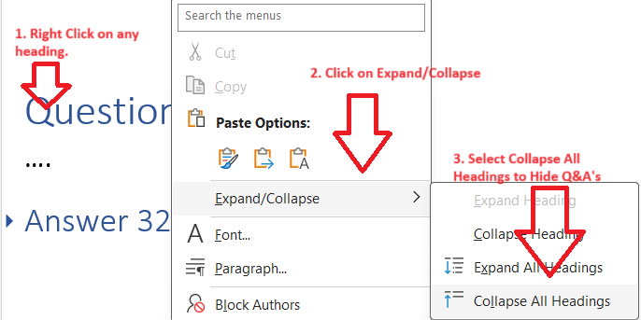

Question 001
The terraform.tfstate file always matches your currently built infrastructure.
- True
- False

Answer 001
Correct Answer: B
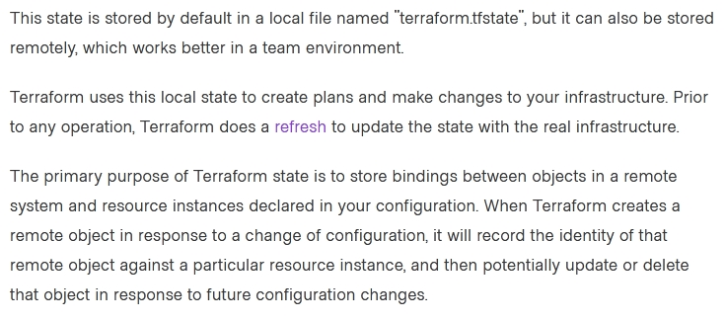
Reference https://www.terraform.io/docs/language/state/index.html

Question 002
One remote backend configuration always maps to a single remote workspace.
- True
- False

Answer 002
Correct Answer: B
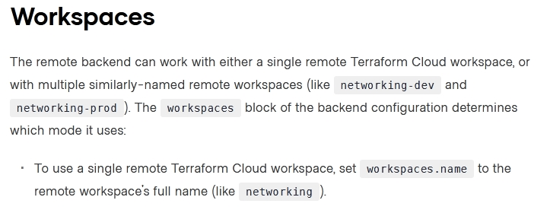
Reference https://www.terraform.io/docs/language/settings/backends/remote.html

Question 003
How is the Terraform remote backend different than other state backends such as S3, Consul, etc.?
- It can execute Terraform runs on dedicated infrastructure on premises or in Terraform Cloud
- It doesn't show the output of a terraform apply locally.
- It is only available to paying customers.
- All of the above

Answer 003
Correct Answer: A
If you and your team are using Terraform to manage meaningful infrastructure, we recommend using the remote backend with Terraform Cloud or Terraform Enterprise
Reference https://www.terraform.io/docs/language/settings/backends/index.html

Question 004
What is the workflow for deploying new infrastructure with Terraform?
- terraform plan to import the current infrastructure to the state file, make code changes, and terraform apply to update the infrastructure.
- Write a Terraform configuration, run terraform show to view proposed changes, and terraform apply to create new infrastructure.
- terraform import to import the current infrastructure to the state file, make code changes, and terraform apply to update the infrastructure.
- Write a Terraform configuration, run terraform init, run terraform plan to view planned infrastructure changes, and terraform apply to create new infrastructure.

Answer 004
Correct Answer: D

Question 005
A provider configuration block is required in every Terraform configuration.
Example:
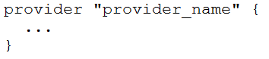
- True
- False

Answer 005
Correct Answer: A (B)
Reference https://github.com/hashicorp/terraform/issues/17928

Question 006
You run a local-exec provisioner in a null resource called null_resource.run_script and realize that you need to rerun the script.
Which of the following commands would you use first?
- terraform taint null_resource.run_script.
- terraform apply -target=null_resource.run_script
- terraform validate null_resource.run_script.
- terraform plan -target=null_resource.run_script

Answer 006
Correct Answer: A
As discussed, the `taint` command used to be the right choice; however, it is deprecated. The right answer is:
terraform apply -replace="null_resource.run_script"

Question 007
Which provisioner invokes a process on the resource created by Terraform?
- remote-exec
- null-exec
- local-exec
- file

Answer 007
Correct Answer: A
The remote-exec provisioner invokes a script on a remote resource after it is created.
Reference https://www.terraform.io/docs/language/resources/provisioners/remote-exec.html

Question 008
Which of the following is not true of Terraform providers?
- Providers can be written by individuals.
- Providers can be maintained by a community of users.
- Some providers are maintained by HashiCorp.
- Major cloud vendors and non-cloud vendors can write, maintain, or collaborate on Terraform providers.
- None of the above

Answer 008
Correct Answer: E
All of the statements are true of Terraform providers.
- Providers can be written by individuals - Any person or organization can develop and distribute a Terraform provider, allowing them to expand Terraform's capabilities to manage resources that it previously could not.
- Providers can be maintained by a community of users - Many Terraform providers are open source projects, and the development and maintenance of these providers can be collaborative efforts between multiple individuals and organizations.
- Some providers are maintained by HashiCorp - HashiCorp, the creators of Terraform, maintain a number of official providers that cover popular infrastructure providers such as AWS, Google Cloud, and Microsoft Azure.
- Major cloud vendors and non-cloud vendors can write, maintain, or collaborate on Terraform providers - Providers can be developed and maintained by cloud vendors, non-cloud vendors, or a combination of both, to expand Terraform's capabilities and support for different types of infrastructure.
Reference
https://jayendrapatil.com/terraform-cheat-sheet/#Terraform_Read_and_write_configuration

Question 009
What command does Terraform require the first time you run it within a configuration directory?
- terraform import.
- terraform init.
- terraform plan.
- terraform workspace.

Answer 009
Correct Answer: B
Reference https://www.terraform.io/docs/cli/commands/init.html

Question 010
You have deployed a new webapp with a public IP address on a cloud provider. However, you did not create any outputs for your code.
What is the best method to quickly find the IP address of the resource you deployed?
- Run terraform output ip_address to view the result.
- In a new folder, use the terraform_remote_state data source to load in the state file, then write an output for each resource that you find the state file.
- Run terraform state list to find the name of the resource, then terraform state show to find the attributes including public IP address.
- Run terraform destroy then terraform apply and look for the IP address in stdout.

Answer 010
Correct Answer: C
Reference https://www.terraform.io/docs/cli/commands/output.html

Question 011
Which of the following is not a key principle of infrastructure as code?
- Versioned infrastructure
- Golden images
- Idempotence
- Self-describing infrastructure

Answer 011
Correct Answer: B
Reference https://docs.microsoft.com/en-us/azure/devops/learn/what-is-infrastructure-as-code#:~:text=Idempotence%20is%20a%20principle%20of,of%20the%20environment's%20starting%20state

Question 012
Terraform variables and outputs that set the "description" argument will store that description in the state file.
- True
- False

Answer 012
Correct Answer: B

Question 013
What is the provider for this fictitious resource?
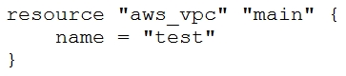
- vpc
- main
- aws
- test

Answer 013
Correct Answer: C
Reference https://docs.aws.amazon.com/cloudformation-cli/latest/userguide/resource-types.htm

Question 014
If you manually destroy infrastructure, what is the best practice reflecting this change in Terraform?
- Run terraform refresh
- It will happen automatically
- Manually update the state file
- Run terraform import

Answer 014
Correct Answer: A

Question 015
What is not processed when running a terraform refresh?
- State file
- Configuration file
- Credentials
- Cloud provider

Answer 015
Correct Answer: B
Reference https://www.terraform.io/docs/cli/commands/refresh.html

Question 016
What information does the public Terraform Module Registry automatically expose about published modules?
- Required input variables
- Optional inputs variables and default values
- Outputs
- All of the above
- None of the above

Answer 016
Correct Answer: D
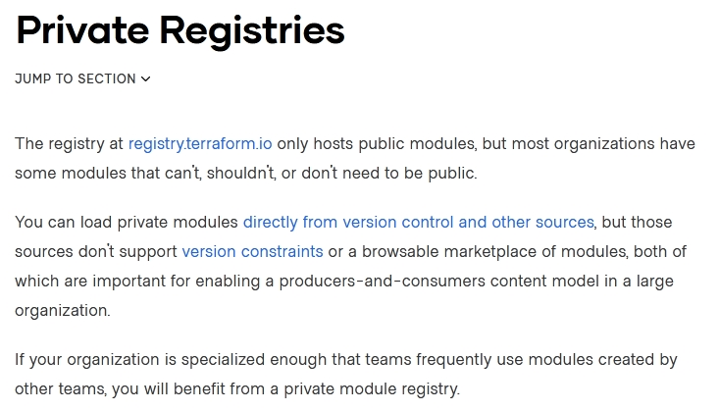
Reference https://www.terraform.io/docs/registry/modules/publish.html

Question 017
If a module uses a local values, you can expose that value with a terraform output.
- True
- False

Answer 017
Correct Answer: A
Output values are like function return values.
Reference https://www.terraform.io/docs/language/values/locals.html
https://www.terraform.io/docs/language/values/outputs.htm

Question 018
You should store secret data in the same version control repository as your Terraform configuration.
- True
- False

Answer 018
Correct Answer: B
Reference https://blog.gruntwork.io/a-comprehensive-guide-to-managing-secrets-in-your-terraform-code-1d586955ace1

Question 019
Which of the following is not a valid string function in Terraform?
- split
- join
- slice
- chomp

Answer 019
Correct Answer: C
Reference https://www.terraform.io/docs/language/functions/chomp.html

Question 020
You have provisioned some virtual machines (VMs) on Google Cloud Platform (GCP) using the gcloud command line tool. However, you are standardizing with Terraform and want to manage these VMs using Terraform instead.
What are the two things you must do to achieve this? (Choose two.)
- Provision new VMs using Terraform with the same VM names.
- Use the terraform import command for the existing VMs.
- Write Terraform configuration for the existing VMs.
- Run the terraform import-gcp command.

Answer 020
Correct Answer: BC
The terraform import command is used to import existing infrastructure.
Import existing Google Cloud resources into Terraform with Terraformer.
Reference https://www.terraform.io/docs/cli/import/usage.html
https://cloud.google.com/docs/terraform

Question 021
You have recently started a new job at a retailer as an engineer. As part of this new role, you have been tasked with evaluating multiple outages that occurred during peak shopping time during the holiday season. Your investigation found that the team is manually deploying new compute instances and configuring each compute instance manually. This has led to inconsistent configuration between each compute instance.
How would you solve this using infrastructure as code?
- Implement a ticketing workflow that makes engineers submit a ticket before manually provisioning and configuring a resource.
- Implement a checklist that engineers can follow when configuring compute instances.
- Replace the compute instance type with a larger version to reduce the number of required deployments.
- Implement a provisioning pipeline that deploys infrastructure configurations committed to your version control system following code reviews.

Answer 021
Correct Answer: D

Question 022
terraform init initializes a sample main.tf file in the current directory.
- True
- False

Answer 022
Correct Answer: B

Question 023
Which two steps are required to provision new infrastructure in the Terraform workflow? (Choose two.)
- Destroy
- Apply
- Import
- Init
- Validate

Answer 023
Correct Answer: BD
Reference https://www.terraform.io/guides/core-workflow.html

Question 024
Why would you use the terraform taint command?
- When you want to force Terraform to destroy a resource on the next apply
- When you want to force Terraform to destroy and recreate a resource on the next apply
- When you want Terraform to ignore a resource on the next apply
- When you want Terraform to destroy all the infrastructure in your workspace

Answer 024
Correct Answer: B
The terraform taint command manually marks a Terraform-managed resource as tainted, forcing it to be destroyed and recreated on the next apply.
IMPORTANT NOTE: taint command is deprecated. For Terraform v0.15.2 and later, Hashicorp recommends using the -replace option with terraform apply instead.
Outdated question for v3.0.0 test.
Although B is correct, but we now have terraform -replace="resource_name" for this now.
Reference https://www.terraform.io/docs/cli/commands/taint.htm

Question 025
Terraform requires the Go runtime as a prerequisite for installation.
- True
- False

Answer 025
Correct Answer: B
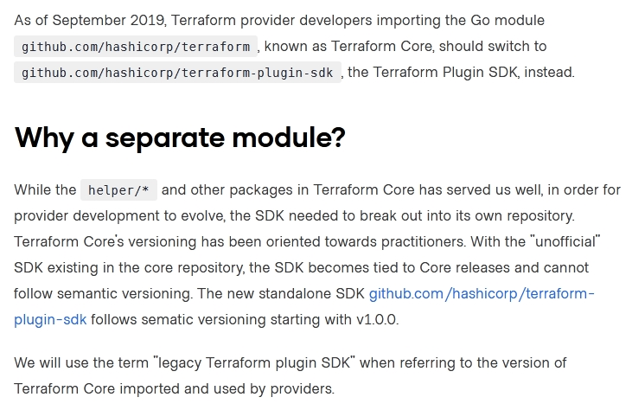
Reference https://www.terraform.io/docs/extend/guides/v1-upgrade-guide.html

Question 026
When should you use the force-unlock command?
- You see a status message that you cannot acquire the lock.
- You have a high priority change.
- Automatic unlocking failed.
- You apply failed due to a state lock.

Answer 026
Correct Answer: C
Manually unlock the state for the defined configuration.
Reference https://www.terraform.io/docs/cli/commands/force-unlock.html

Question 027
Terraform can import modules from a number of sources; which of the following is not a valid source?
- FTP server
- GitHub repository
- Local path
- Terraform Module Registry

Answer 027
Correct Answer: A

Question 028
Which of the following is available only in Terraform Enterprise or Cloud workspaces and not in Terraform CLI?
- Secure variable storage
- Support for multiple cloud providers
- Dry runs with terraform plan.
- Using the workspace as a data source

Answer 028
Correct Answer: A

Question 029
terraform validate validates the syntax of Terraform files.
- True
- False

Answer 029
Correct Answer: A
The terraform validate command validates the syntax and arguments of the Terraform configuration files.
Reference https://www.terraform.io/docs/cli/code/index.html

Question 030
You have used Terraform to create an ephemeral development environment in the cloud and are now ready to destroy all the infrastructure described by your Terraform configuration. To be safe, you would like to first see all the infrastructure that will be deleted by Terraform.
Which command should you use to show all of the resources that will be deleted? (Choose two.)
- Run terraform plan -destroy.
- This is not possible. You can only show resources that will be created.
- Run terraform state rm *.
- Run terraform destroy and it will first output all the resources that will be deleted before prompting for approval.

Answer 030
Correct Answer: AD
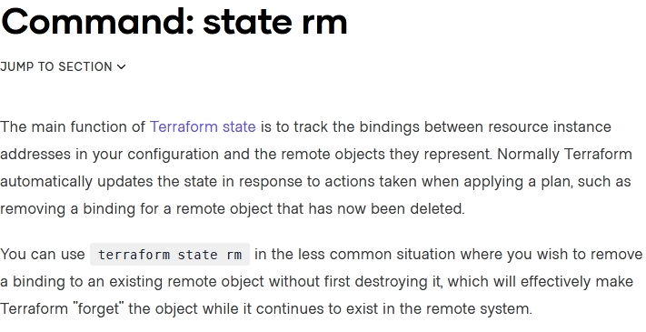
Reference https://www.terraform.io/docs/cli/commands/state/rm.htm

Question 031
Which of the following is the correct way to pass the value in the variable num_servers into a module with the input servers?
- servers = num_servers
- servers = variable.num_servers
- servers = var(num_servers)
- servers = var.num_servers

Answer 031
Correct Answer: D

Question 032
A Terraform provisioner must be nested inside a resource configuration block.
- True
- False

Answer 032
Correct Answer: A
Provisioners are used to execute scripts on a local or remote machine as part of resource creation or destruction. Provisioners can be used to bootstrap a resource, cleanup before destroy, run configuration management, etc.
How to use Provisioners
Note: Provisioners should only be used as a last resort. For most common situations there are better alternatives.
If you are certain that provisioners are the best way to solve your problem after considering the advice in the sections above, you can add a provisioner block inside the resource block of a compute instance.
Reference https://developer.hashicorp.com/terraform/language/resources/provisioners/syntax

Question 033
Terraform can run on Windows or Linux, but it requires a Server version of the Windows operating system.
- True
- False

Answer 033
Correct Answer: B

Question 034
What does the default "local" Terraform backend store?
- tfplan files
- Terraform binary
- Provider plugins
- State file

Answer 034
Correct Answer: D
Reference https://www.terraform.io/docs/language/settings/backends/local.html

Question 035
You have multiple team members collaborating on infrastructure as code (IaC) using Terraform and want to apply formatting standards for readability.
How can you format Terraform HCL (HashiCorp Configuration Language) code according to standard Terraform style convention?
- Run the terraform fmt command during the code linting phase of your CI/CD process
- Designate one person in each team to review and format everyone's code
- Manually apply two spaces indentation and align equal sign "=" characters in every Terraform file (*.tf)
- Write a shell script to transform Terraform files using tools such as AWK, Python, and sed

Answer 035
Correct Answer: A
Reference https://www.terraform.io/docs/language/syntax/style.html

Question 036
What value does the Terraform Cloud/Terraform Enterprise private module registry provide over the public Terraform Module Registry?
- The ability to share modules with public Terraform users and members of Terraform Enterprise Organizations
- The ability to tag modules by version or release.
- The ability to restrict modules to members of Terraform Cloud or Enterprise organizations.
- The ability to share modules publicly with any user of Terraform.

Answer 036
Correct Answer: C
Reference https://www.terraform.io/docs/language/modules/sources.html

Question 037
Which task does terraform init not perform?
- Sources all providers present in the configuration and ensures they are downloaded and available locally.
- Connects to the backend.
- Sources any modules and copies the configuration locally.
- Validates all required variables are present.

Answer 037
Correct Answer: D
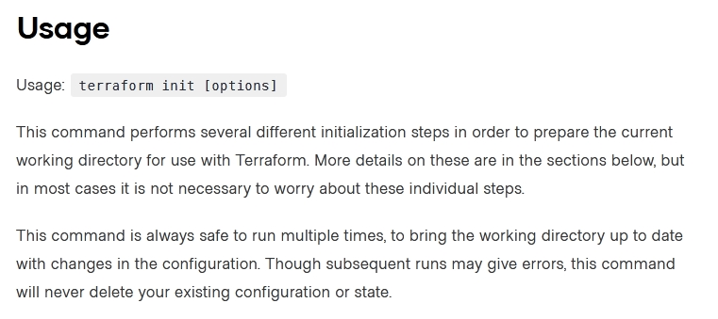
Reference https://www.terraform.io/docs/cli/commands/init.html

Question 038
You have declared a variable called var.list which is a list of objects that all have an attribute id.
Which options will produce a list of the IDs? (Choose two.)
- { for o in var.list : o => o.id }
- var.list[*].id
- [ var.list[*].id ]
- [ for o in var.list : o.id ]

Answer 038
Correct Answer: BD
You can retrieve the list of IDs in your Terraform configuration using either of these options:
output "users_splat" {
value = var.users[*].id
}
output "users_for" {
value = [for user in var.users : user.id]
}
Both these outputs will produce the same list of IDs: ["id1", "id2", "id3"].

Question 039
Which argument(s) is (are) required when declaring a Terraform variable?
- type
- default
- description
- All of the above
- None of the above

Answer 039
Correct Answer: E
Terraform CLI defines the following OPTIONAL arguments for variable declarations:
- default - A default value which then makes the variable optional.
- type - This argument specifies what value types are accepted for the variable.
- description - This specifies the input variable's documentation.
- validation - A block to define validation rules, usually in addition to type constraints.
- sensitive - Limits Terraform UI output when the variable is used in configuration.
- nullable - Specify if the variable can be null within the module.
Reference https://www.terraform.io/docs/language/values/variables.html

Question 040
When using a module block to reference a module stored on the public Terraform Module Registry such as:
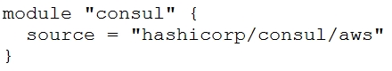
How do you specify version 1.0.0?
- Modules stored on the public Terraform Module Registry do not support versioning
- Append ?ref=v1.0.0 argument to the source path
- Add version = "1.0.0" attribute to module block
- Nothing modules stored on the public Terraform Module Registry always default to version 1.0.0.

Answer 040
Correct Answer: C

Question 041
What features does the hosted service Terraform Cloud provide? (Choose two.)
- Automated infrastructure deployment visualization
- Automatic backups
- Remote state storage
- A web-based user interface (UI).

Answer 041
Correct Answer: CD
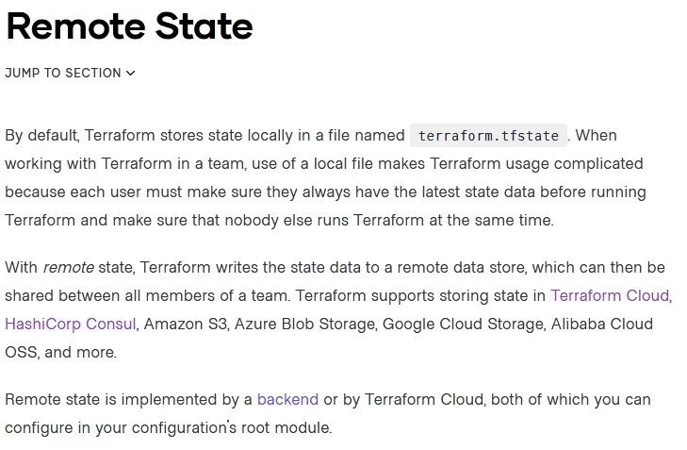
Reference https://www.terraform.io/docs/enterprise/admin/automated-recovery.html https://www.terraform.io/docs/language/state/remote.html

Question 042
Where does the Terraform local backend store its state?
- In the /tmp directory
- In the terraform file
- In the terraform.tfstate file
- In the user's terraform.state file.

Answer 042
Correct Answer: C
The local backend stores state on the local filesystem, locks that state using system APIs, and performs operations locally.
Reference https://www.terraform.io/docs/language/settings/backends/local.html

Question 043
Which option cannot be used to keep secrets out of Terraform configuration files?
- A Terraform provider.
- Environment variables
- A -var flag
- secure string.

Answer 043
Correct Answer: D
Terraform does not have a built-in concept of a "secure string". This means that you cannot use the secure_string keyword to define a secret in your Terraform configuration file.
Link below recommends the three options.
- e.g. Vault
- e.g. export TF_VAR_db_username=admin TF_VAR_db_password=adifferentpassword
- -var-file="secret.tfvars"
Reference https://secrethub.io/blog/secret-management-for-terraform/

Question 044
What is one disadvantage of using dynamic blocks in Terraform?
- They cannot be used to loop through a list of values.
- Dynamic blocks can construct repeatable nested blocks.
- They make configuration harder to read and understand.
- Terraform will run more slowly.

Answer 044
Correct Answer: C
Reference https://github.com/hashicorp/terraform/issues/19291

Question 045
Only the user that generated a plan may apply it.
- True
- False.

Answer 045
Correct Answer: B

Question 046
Examine the following Terraform configuration, which uses the data source for an AWS AMI.
What value should you enter for the ami argument in the AWS instance resource?
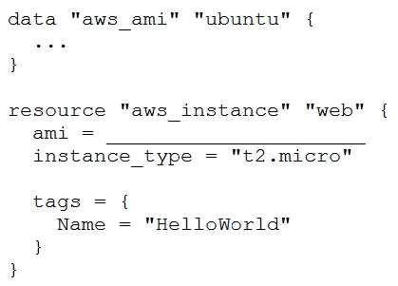
- aws_ami.ubuntu
- data.aws_ami.ubuntu
- data.aws_ami.ubuntu.id
- aws_ami.ubuntu.id

Answer 046
Correct Answer: C
resource "aws_instance" "web" {
ami = data.aws_ami.ubuntu.id
Reference https://registry.terraform.io/providers/hashicorp/aws/latest/docs/resources/instance

Question 047
FILL BLANK -
You need to specify a dependency manually.
What resource meta-parameter can you use to make sure Terraform respects the dependency?
Type your answer in the field provided. The text field is not case-sensitive and all variations of the correct answer are accepted.

Answer 047
Correct Answer: depends_on

Question 048
You have never used Terraform before and would like to test it out using a shared team account for a cloud provider. The shared team account already contains 15 virtual machines (VM). You develop a Terraform configuration containing one VM, perform terraform apply, and see that your VM was created successfully.
What should you do to delete the newly-created VM with Terraform?
- The Terraform state file contains all 16 VMs in the team account. Execute terraform destroy and select the newly-created VM.
- The Terraform state file only contains the one new VM. Execute terraform destroy.
- Delete the Terraform state file and execute Terraform apply.
- Delete the VM using the cloud provider console and terraform apply to apply the changes to the Terraform state file.

Answer 048
Correct Answer: B

Question 049
What is the name assigned by Terraform to reference this resource?
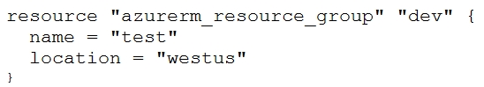
- dev
- azurerm_resource_group
- azurerm
- test

Answer 049
Correct Answer: A

Question 050
Setting the TF_LOG environment variable to DEBUG causes debug messages to be logged into syslog.
- True
- False.

Answer 050
Correct Answer: B
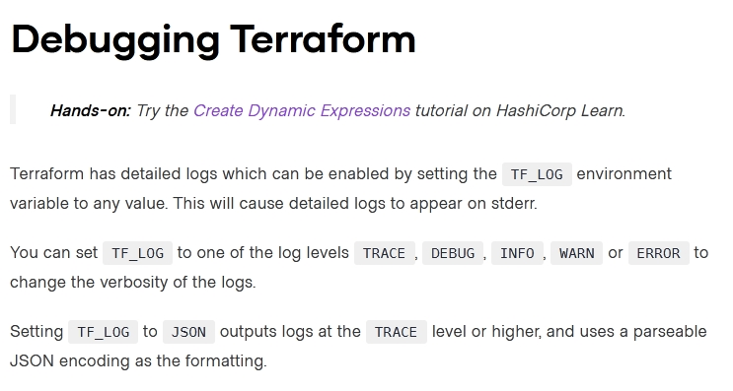
Reference https://www.terraform.io/docs/internals/debugging.html

Question 051
Where in your Terraform configuration do you specify a state backend?
- The terraform block
- The resource block
- The provider block
- The datasource block.

Answer 051
Correct Answer: A
Backends are configured with a nested backend block within the top-level terraform block
Reference https://www.terraform.io/docs/language/settings/backends/configuration.html

Question 052
In Terraform 0.13 and above, outside of the required_providers block, Terraform configurations always refer to providers by their local names.
- True
- False.

Answer 052
Correct Answer: A
Outside of the required_providers block, Terraform configurations always refer to providers by their local names.
Reference https://www.terraform.io/docs/language/providers/requirements.html

Question 053
What command should you run to display all workspaces for the current configuration?
- terraform workspace
- terraform workspace show
- terraform workspace list
- terraform show workspace.

Answer 053
Correct Answer: C
terraform workspace list
The command will list all existing workspaces.
Reference https://www.terraform.io/docs/cli/commands/workspace/list.html

Question 054
Terraform providers are always installed from the Internet.
- True
- False

Answer 054
Correct Answer: B
Terraform configurations must declare which providers they require, so that Terraform can install and use them.
Reference https://www.terraform.io/docs/language/providers/configuration.html

Question 055
Which of these is the best practice to protect sensitive values in state files?
- Blockchain
- Secure Sockets Layer (SSL)
- Enhanced remote backends
- Signed Terraform providers

Answer 055
Correct Answer: C
Use of remote backends and especially the availability of Terraform Cloud, there are now a variety of backends that will encrypt state at rest and will not store the state in cleartext on machines running.
Reference https://www.terraform.io/docs/extend/best-practices/sensitive-state.html

Question 056
When does terraform apply reflect changes in the cloud environment?
- Immediately
- However long it takes the resource provider to fulfill the request
- After updating the state file
- Based on the value provided to the -refresh command line argument
- None of the above.

Answer 056
Correct Answer: B

Question 057
How would you reference the "name" value of the second instance of this fictitious resource?
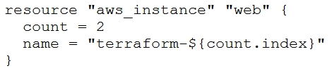
- element(aws_instance.web, 2)
- aws_instance.web[1].name
- aws_instance.web[1]
- aws_instance.web[2].name
- aws_instance.web.*.name.

Answer 057
Correct Answer: B
Reference https://www.terraform.io/docs/configuration-0-11/interpolation.html

Question 058
A Terraform provider is not responsible for:
- Understanding API interactions with some service
- Provisioning infrastructure in multiple clouds
- Exposing resources and data sources based on an API
- Managing actions to take based on resource differences.

Answer 058
Correct Answer: B
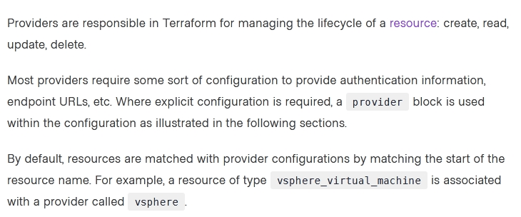
Reference https://www.terraform.io/docs/configuration-0-11/providers.html

Question 059
Terraform provisioners can be added to any resource block.
- True
- False.

Answer 059
Correct Answer: A
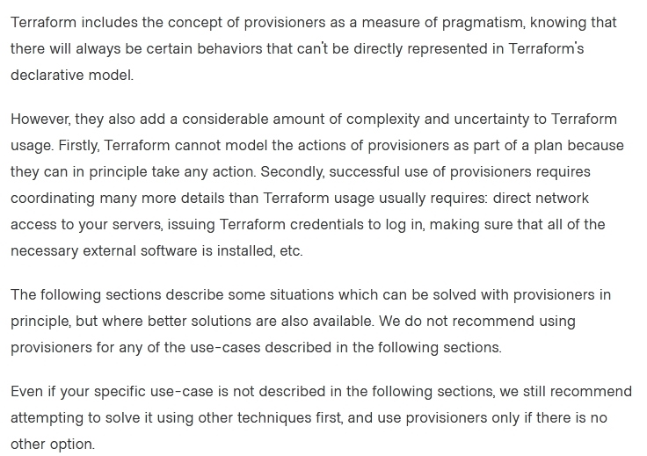
Reference https://www.terraform.io/docs/language/resources/provisioners/syntax.html

Question 060
What is terraform refresh intended to detect?
- Terraform configuration code changes
- Empty state files
- State file drift
- Corrupt state files.

Answer 060
Correct Answer: C
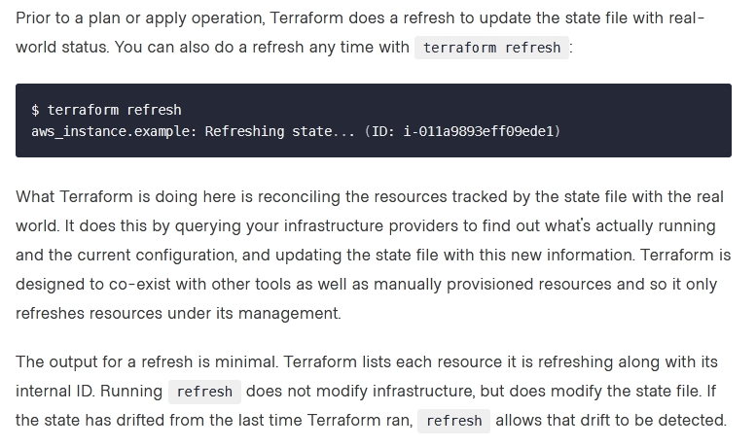
Reference https://www.hashicorp.com/blog/detecting-and-managing-drift-with-terraform

Question 061
FILL BLANK -
Which flag would you add to terraform plan to save the execution plan to a file?
Type your answer in the field provided. The text field is not case-sensitive and all variations of the correct answer are accepted.

Answer 061
Correct Answer: -out=FILENAME
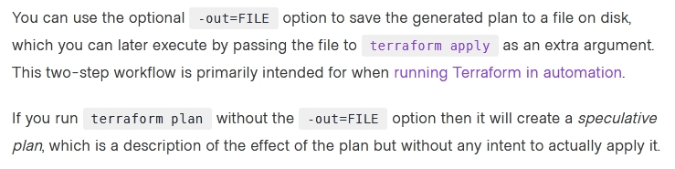
Reference https://www.terraform.io/docs/cli/commands/plan.html

Question 062
FILL BLANK -
What is the name of the default file where Terraform stores the state?
Type your answer in the field provided. The text field is not case-sensitive and all variations of the correct answer are accepted.

Answer 062
Correct Answer: terraform.tfstate
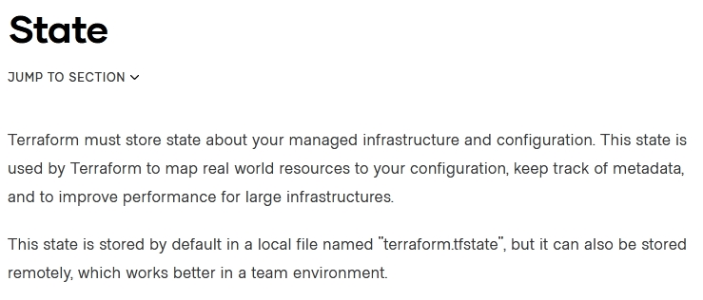
Reference https://www.terraform.io/docs/language/state/index.html

Question 063
A Terraform local value can reference other Terraform local values.
- True
- False.

Answer 063
Correct Answer: A
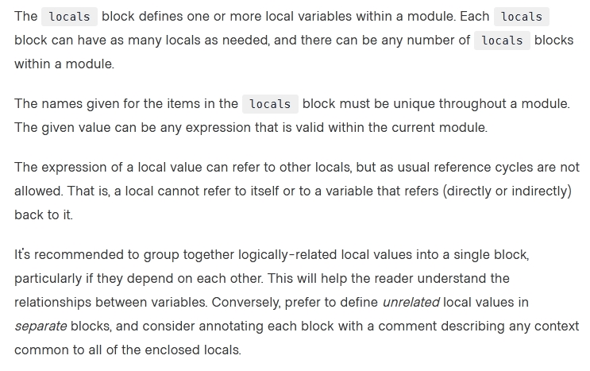
Reference https://www.terraform.io/docs/configuration-0-11/locals.html

Question 064
Which of the following is not a valid Terraform collection type?
- list
- map
- tree
- set

Answer 064
Correct Answer: C
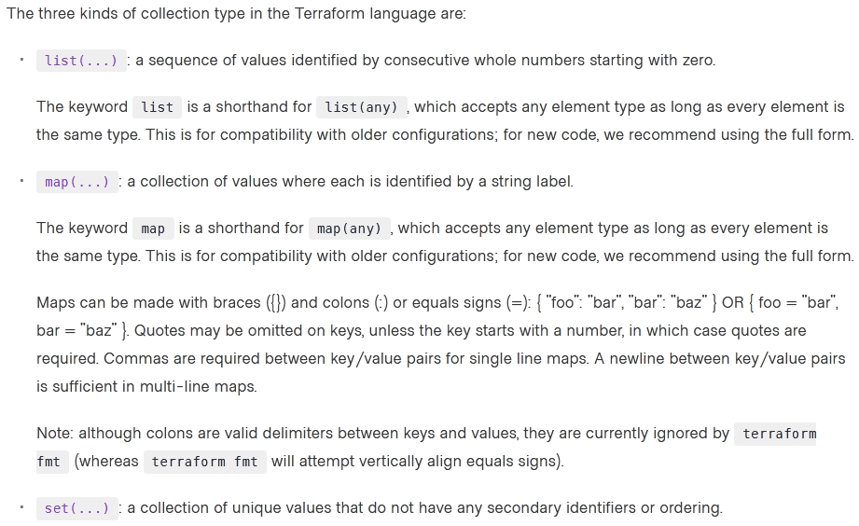
Reference https://www.terraform.io/docs/language/expressions/type-constraints.html

Question 065
When running the command terraform taint against a managed resource you want to force recreation upon, Terraform will immediately destroy and recreate the resource.
- True
- False

Answer 065
Correct Answer: B
Mark as taint until next apply, then destroys and recreates.
Reference https://www.devopsschool.com/blog/terraform-taint-and-untaint-explained-with-example-programs-and-tutorials/

Question 066
All standard backend types support state storage, locking, and remote operations like plan, apply and destroy.
- True
- False

Answer 066
Correct Answer: A

Question 067
How can terraform plan aid in the development process?
- Validates your expectations against the execution plan without permanently modifying state
- Initializes your working directory containing your Terraform configuration files
- Formats your Terraform configuration files
- Reconciles Terraform state against deployed resources and permanently modifies state using the current status of deployed resources.

Answer 067
Correct Answer: A
Reference https://github.com/hashicorp/terraform/issues/19235

Question 068
You would like to reuse the same Terraform configuration for your development and production environments with a different state file for each.
Which command would you use?
- terraform import
- terraform workspace
- terraform state
- terraform init

Answer 068
Correct Answer: B

Question 069
What is the name assigned by Terraform to reference this resource?
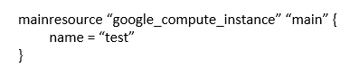
- compute_instance
- main
- google
- teat

Answer 069
Correct Answer: B

Question 070
You're building a CI/CD (continuous integration/ continuous delivery) pipeline and need to inject sensitive variables into your Terraform run.
How can you do this safely?
- Pass variables to Terraform with a -var flag.
- Copy the sensitive variables into your Terraform code.
- Store the sensitive variables in a secure_vars.tf file.
- Store the sensitive variables as plain text in a source code repository.

Answer 070
Correct Answer: A

Question 071
Your security team scanned some Terraform workspaces and found secrets stored in a plaintext in state files.
How can you protect sensitive data stored in Terraform state files?
- Delete the state file every time you run Terraform.
- Store the state in an encrypted backend.
- Edit your state file to scrub out the sensitive data.
- Always store your secrets in a secrets.tfvars file.

Answer 071
Correct Answer: B
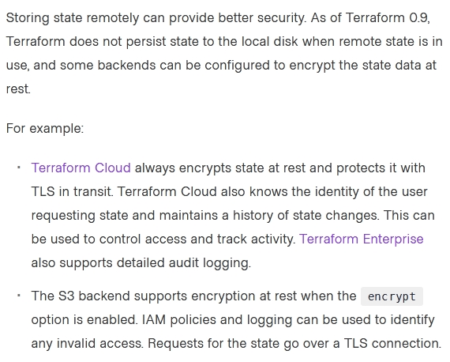
Reference https://www.terraform.io/docs/language/state/sensitive-data.html

Question 072
In contrast to Terraform Open Source, when working with Terraform Enterprise and Cloud Workspaces, conceptually you could think about them as completely separate working directories.
- True
- False.

Answer 072
Correct Answer: A

Question 073
You want to know from which paths Terraform is loading providers referenced in your Terraform configuration (*.tf files). You need to enable debug messages to find this out.
Which of the following would achieve this?
- Set the environment variable TF_LOG=TRACE
- Set verbose logging for each provider in your Terraform configuration.
- Set the environment variable TF_VAR_log=TRACE
- Set the environment variable TF_LOG_PATH.

Answer 073
Correct Answer: A
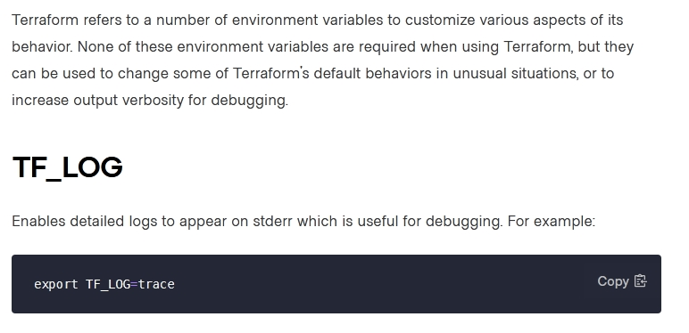
Reference https://www.terraform.io/docs/cli/config/environment-variables.html

Question 074
How is terraform import run?
- As a part of terraform init
- As a part of terraform plan
- As a part of terraform refresh
- By an explicit call
- All of the above.

Answer 074
Correct Answer: D
Latest version of Terraform can import as part of apply in case you have import {} clauses.
Since this is not part of the answers, explicit call remains, answer D.

Question 075
You have a simple Terraform configuration containing one virtual machine (VM) in a cloud provider. You run terraform apply and the VM is created successfully.
What will happen if you delete the VM using the cloud provider console, and run terraform apply again without changing any Terraform code?
- Terraform will remove the VM from state file.
- Terraform will report an error.
- Terraform will not make any changes.
- Terraform will recreate the VM.

Answer 075
Correct Answer: D

Question 076
Which of these options is the most secure place to store secrets for connecting to a Terraform remote backend?
- Defined in Environment variables.
- Inside the backend block within the Terraform configuration
- Defined in a connection configuration outside of Terraform.
- None of above.

Answer 076
Correct Answer: A
Reference
https://www.terraform.io/language/settings/backends/configuration#credentials-and-sensitive-data

Question 077
Your DevOps team is currently using the local backend for your Terraform configuration. You would like to move to a remote backend to begin storing the state file in a central location.
Which of the following backends would not work?
- Amazon S3
- Artifactory
- Git
- Terraform Cloud.

Answer 077
Correct Answer: C
Reference https://secrethub.io/blog/secret-management-for-terraform/

Question 078
Which backend does the Terraform CLI use by default?
- Terraform Cloud
- Consul
- Remote
- Local

Answer 078
Correct Answer: D
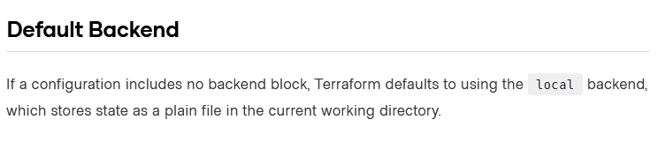
Reference https://www.terraform.io/docs/language/settings/backends/configuration.html

Question 079
When you initialize Terraform, where does it cache modules from the public Terraform Module Registry?
- On disk in the /tmp directory
- In memory
- On disk in the .terraform sub-directory
- They are not cached.

Answer 079
Correct Answer: C
Reference https://www.terraform.io/docs/language/modules/sources.html

Question 080
You write a new Terraform configuration and immediately run terraform apply in the CLI using the local backend.
Why will the apply fail?
- Terraform needs you to format your code according to best practices first
- Terraform needs to install the necessary plugins first
- The Terraform CLI needs you to log into Terraform cloud first
- Terraform requires you to manually run terraform plan first.

Answer 080
Correct Answer: B

Question 081
What features stops multiple admins from changing the Terraform state at the same time?
- Version control
- Backend types
- Provider constraints
- State locking

Answer 081
Correct Answer: D
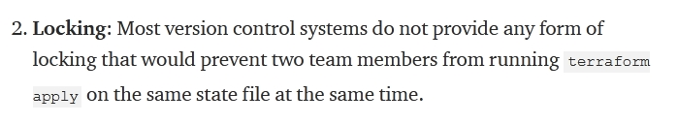
Reference https://blog.gruntwork.io/how-to-manage-terraform-state-28f5697e68fa

Question 082
A fellow developer on your team is asking for some help in refactoring their Terraform code. As part of their application's architecture, they are going to tear down an existing deployment managed by Terraform and deploy new. However, there is a server resource named aws_instance.ubuntu[1] they would like to keep performing some additional analysis.
What command should be used to tell Terraform to no longer manage the resource?
- terraform apply rm aws_instance.ubuntu[1]
- terraform state rm aws_instance.ubuntu[1]
- terraform plan rm aws_instance.ubuntu[1]
- terraform delete aws_instance.ubuntu[1].

Answer 082
Correct Answer: B
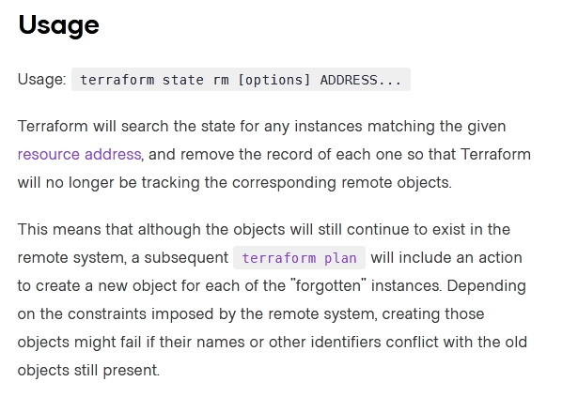
Reference https://www.terraform.io/docs/cli/commands/state/rm.html

Question 083
Terraform can only manage resource dependencies if you set them explicitly with the depends_on argument.
- True
- False.

Answer 083
Correct Answer: B
Reference https://learn.hashicorp.com/tutorials/terraform/dependencies?in=terraform/0-13

Question 084
A terraform apply can not _________ infrastructure.
- change
- destroy
- provision
- import

Answer 084
Correct Answer: D*
*with the new “import” block, in fact, it can.

Question 085
You need to constrain the GitHub provider to version 2.1 or greater.
Which of the following should you put into the Terraform 0.12 configuration's provider block?
- version >= 2.1
- version ~> 2.1
- version = "<= 2.1"
- version = ">= 2.1"

Answer 085
Correct Answer: D
Reference https://github.com/hashicorp/terraform-provider-null/issues/31

Question 086
You just scaled your VM infrastructure and realized you set the count variable to the wrong value. You correct the value and save your change.
What do you do next to make your infrastructure match your configuration?
- Run an apply and confirm the planned changes.
- Inspect your Terraform state because you want to change it.
- Reinitialize because your configuration has changed.
- Inspect all Terraform outputs to make sure they are correct.

Answer 086
Correct Answer: A

Question 087
Terraform provisioners that require authentication can use the ______ block.
- connection
- credentials
- secrets
- ssh.

Answer 087
Correct Answer: A

Question 088
Terraform validate reports syntax check errors from which of the following scenarios?
- Code contains tabs indentation instead of spaces
- There is missing value for a variable
- The state files does not match the current infrastructure
- None of the above.

Answer 088
Correct Answer: B
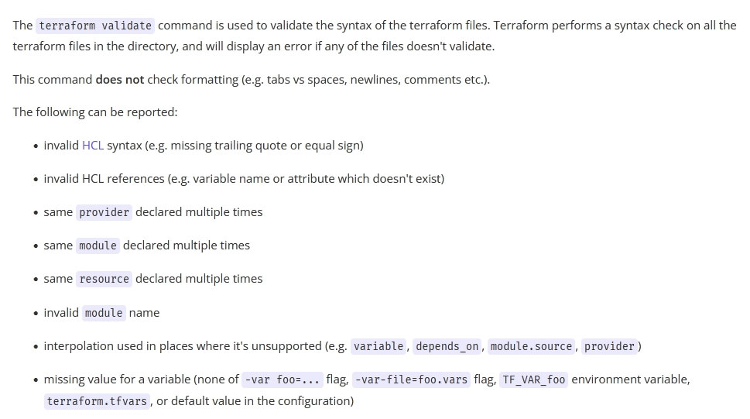
Reference http://man.hubwiz.com/docset/Terraform.docset/Contents/Resources/Documents/docs/commands/validate.html

Question 089
Which of the following is allowed as a Terraform variable name?
- count
- name
- source
- version

Answer 089
Correct Answer: B
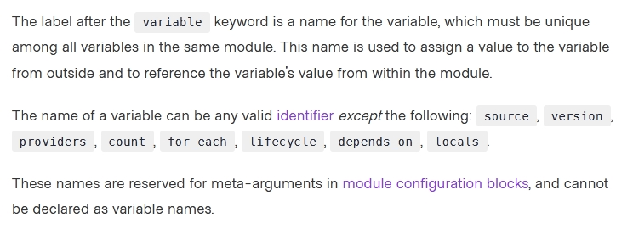
Reference https://www.terraform.io/docs/language/values/variables.html

Question 090
What type of block is used to construct a collection of nested configuration blocks?
- for_each
- repeated
- nesting
- dynamic

Answer 090
Correct Answer: D
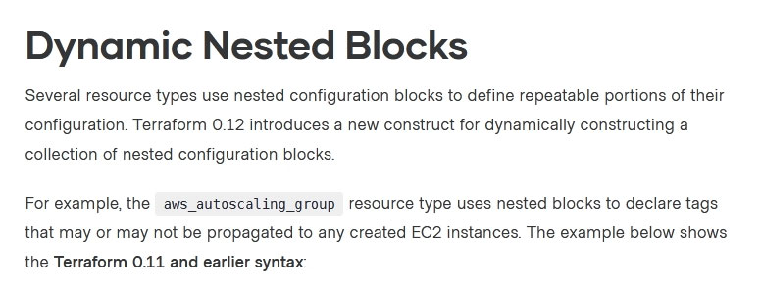
Reference https://www.hashicorp.com/blog/hashicorp-terraform-0-12-preview-for-and-for-each

Question 091
Module variable assignments are inherited from the parent module and do not need to be explicitly set.
- True
- False.

Answer 091
Correct Answer: B
Modules do not inherit variables from the parent module. All modules are self-contained units. So, you have to explicitly define variables in the child module, and then explicit set these variables in the parent module, when you instantiate the child module.
Reference https://github.com/hashicorp/terraform/issues/15818

Question 092
If writing Terraform code that adheres to the Terraform style conventions, how would you properly indent each nesting level compared to the one above it?
- With four spaces
- With a tab
- With three spaces
- With two spaces

Answer 092
Correct Answer: D
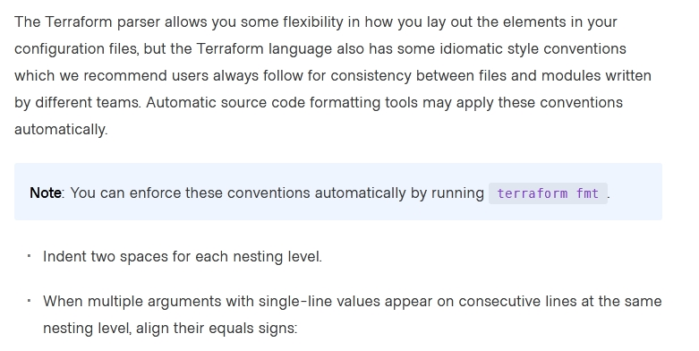
Reference https://www.terraform.io/docs/language/syntax/style.html

Question 093
Which of the following is not an action performed by terraform init?
- Create a sample main.tf file
- Initialize a configured backend
- Retrieve the source code for all referenced modules
- Load required provider plugins.

Answer 093
Correct Answer: A
Reference https://www.terraform.io/docs/cli/init/index.html

Question 094
HashiCorp Configuration Language (HCL) supports user-defined functions.
- True
- False.

Answer 094
Correct Answer: B
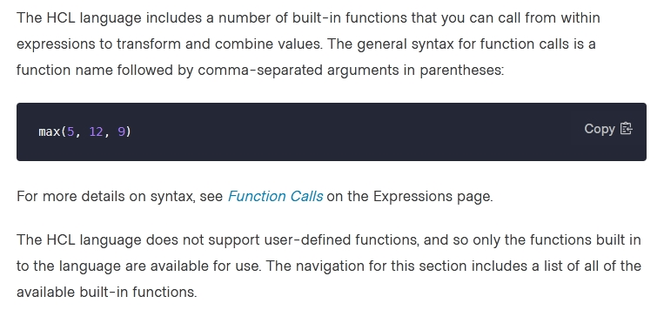
Reference https://www.packer.io/docs/templates/hcl_templates/functions

Question 095
How can you trigger a run in a Terraform Cloud workspace that is connected to a Version Control System (VCS) repository?
- Only Terraform Cloud organization owners can set workspace variables on VCS connected workspaces.
- Commit a change to the VCS working directory and branch that the Terraform Cloud workspace is connected to.
- Only members of a VCS organization can open a pull request against repositories that are connected to Terraform Cloud workspaces.
- Only Terraform Cloud organization owners can approve plans in VCS connected workspaces.

Answer 095
Correct Answer: B
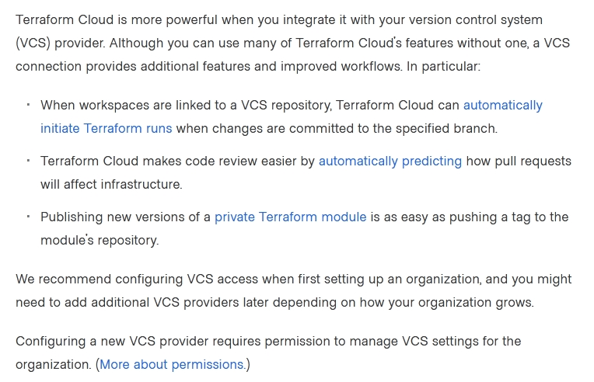
Reference https://www.terraform.io/docs/cloud/vcs/index.html

Question 096
Terraform and Terraform providers must use the same major version number in a single configuration.
- True
- False

Answer 096
Correct Answer: B
Reference https://www.terraform.io/docs/language/expressions/version-constraints.html

Question 097
Which statement describes a goal of infrastructure as code?
- An abstraction from vendor specific APIs
- Write once, run anywhere.
- A pipeline process to test and deliver software.
- The programmatic configuration of resources.

Answer 097
Correct Answer: D

Question 098
When using Terraform to deploy resources into Azure, which scenarios are true regarding state files? (Choose two.)
- When a change is made to the resources via the Azure Cloud Console, the changes are recorded in a new state file.
- When a change is made to the resources via the Azure Cloud Console, Terraform will update the state file to reflect them during the next plan or apply.
- When a change is made to the resources via the Azure Cloud Console, the current state file will not be updated.
- When a change is made to the resources via the Azure Cloud Console, the changes are recorded in the current state file.

Answer 098
Correct Answer: BC

Question 099
You need to deploy resources into two different cloud regions in the same Terraform configuration. To do that, you declare multiple provider configurations as follows:
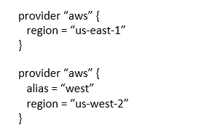
What meta-argument do you need to configure in a resource block to deploy the resource to the `us-west-2` AWS region?
- alias = west
- provider = west
- provider = aws.west
- alias = aws.west.

Answer 099
Correct Answer: C
Reference https://github.com/hashicorp/terraform/issues/451

Question 100
You have declared an input variable called environment in your parent module. What must you do to pass the value to a child module in the configuration?
- Add node_count = var.node_count
- Declare the variable in a terraform.tfvars file.
- Declare a node_count input variable for child module.
- Nothing, child modules inherit variables of parent module.

Answer 100
Correct Answer: C
When passing variables from a parent module to a child module in Terraform, you need to explicitly declare the variables in both the parent and the child modules. In this case, you would need to declare an input variable for the child module that corresponds to the input variable declared in the parent module. So, the correct option is C.
Option A is incorrect because it is using an example variable that is not related to the input variable mentioned in the question. Option B is incorrect because it refers to how to set the value of the variable, but not how to pass the value from the parent to the child module. Option D is also incorrect because child modules do not automatically inherit the variables of their parent modules.

Question 101
If a module declares a variable with a default, that variable must also be defined within the module.
- True
- False

Answer 101
Correct Answer: B
If a module declares a variable with a default value, it is not necessary to define the variable within the module calling the module. The module will automatically use the default value if a value is not explicitly assigned to the variable in the calling module

Question 102
Which option cannot be used to keep secrets out of Terraform configuration files?
- Environment Variables
- Mark the variable as sensitive.
- A Terraform provider.
- A -var flag.

Answer 102
Correct Answer: B
- Environment Variables: This method keeps secrets out of configuration files by setting them externally.
- Mark the variable as sensitive: While this marks the variable as sensitive in Terraform's state and prevents it from being displayed in CLI outputs, the secret can still be present in the configuration files and state file.
- A Terraform provider: This doesn't inherently store or hide secrets in configuration files.
- A -var flag: This method can be used to pass variables at runtime, thus keeping them out of configuration files.
Reference https://developer.hashicorp.com/terraform/tutorials/configuration-language/sensitive-variable

Question 103
Which of the following arguments are required when declaring a Terraform output?
- sensitive
- description
- default
- value

Answer 103
Correct Answer: D

Question 104
Your risk management organization requires that new AWS S3 buckets must be private and encrypted at rest. How can Terraform Enterprise automatically and proactively enforce this security control?
- With a Sentinel policy, which runs before every apply.
- By adding variables to each TFE workspace to ensure these settings are always enabled
- With an S3 module with proper settings for buckets
- Auditing cloud storage buckets with a vulnerability scanning tool.

Answer 104
Correct Answer: A

Question 105
Most Terraform providers interact with ____________.
- API
- VCS Systems
- Shell scripts
- None of the above.

Answer 105
Correct Answer: A

Question 106
terraform validate validates that your infrastructure matches the Terraform state file.
- True
- False

Answer 106
Correct Answer: B

Question 107
What does terraform import allow you to do?
- Import a new Terraform module
- Use a state file to import infrastructure to the cloud
- Import provisioned infrastructure to your state file
- Import an existing state file to a new Terraform workspace.

Answer 107
Correct Answer: C

Question 108
FILL BLANK -
In the below configuration, how would you reference the module output vpc_id?
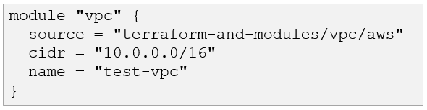
Type your answer in the field provided. The text field is not case sensitive and all variations of the correct answer are accepted.

Answer 108
Correct Answer: module.vpc.vpc_id

Question 109
How would you reference the Volume IDs associated with the ebs_block_device blocks in this configuration?
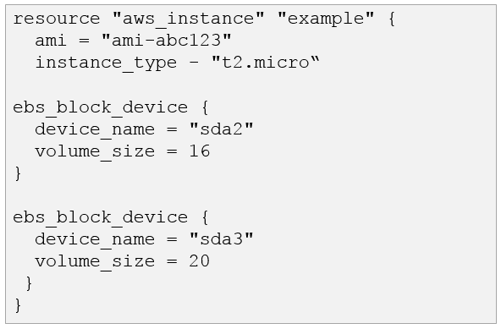
- aws_instance.example.ebs_block_device.[*].volume_id
- aws_instance.example.ebs_block_device.volume_id
- aws_instance.example.ebs_block_device[sda2,sda3].volume_id
- aws_instance.example.ebs_block_device.*.volume_id.

Answer 109
Correct Answer: D
The brackets do not work, asterisk only.

Question 110
What does state locking accomplish?
- Copies the state file from memory to disk
- Encrypts any credentials stored within the state file
- Blocks Terraform commands from modifying the state file
- Prevents accidental deletion of the state file.

Answer 110
Correct Answer: C
Reference https://www.terraform.io/language/state/locking

Question 111
You just upgraded the version of a provider in an existing Terraform project. What do you need to do to install the new provider?
- Run terraform apply -upgrade
- Run terraform init -upgrade
- Run terraform refresh
- Upgrade your version of Terraform.

Answer 111
Correct Answer: B

Question 112
A module can always refer to all variables declared in its parent module.
- True
- False.

Answer 112
Correct Answer: A
A module can always refer to all variables declared in its parent module.

Question 113
When you use a remote backend that needs authentication, HashiCorp recommends that you:
- Use partial configuration to load the authentication credentials outside of the Terraform code.
- Push your Terraform configuration to an encrypted git repository.
- Write the authentication credentials in the Terraform configuration files.
- Keep the Terraform configuration files in a secret store.

Answer 113
Correct Answer: A

Question 114
You have a simple Terraform configuration containing one virtual machine (VM) in a cloud provider. You run terraform apply and the VM is created successfully.
What will happen if you terraform apply again immediately afterwards without changing any Terraform code?
- Terraform will terminate and recreate the VM.
- Terraform will create another duplicate VM.
- Terraform will apply the VM to the state file.
- Nothing.

Answer 114
Correct Answer: D

Question 115
A junior admin accidentally deleted some of your cloud instances. What does Terraform do when you run terraform apply?
- Build a completely brand new set of infrastructure.
- Tear down the entire workspace infrastructure and rebuild it.
- Rebuild only the instances that were deleted.
- Stop and generate an error message about the missing instances.

Answer 115
Correct Answer: C

Question 116
You have created a main.tf Terraform configuration consisting of an application server, a database, and a load balancer. You ran terraform apply and all resources were created successfully. Now you realize that you do not actually need the load balancer so you run terraform destroy without any flags What will happen?
- Terraform will destroy the application server because it is listed first in the code.
- Terraform will prompt you to confirm that you want to destroy all the infrastructure.
- Terraform will destroy the main.tf file.
- Terraform will prompt you to pick which resource you want to destroy.
- Terraform will immediately destroy all the infrastructure.

Answer 116
Correct Answer: B

Question 117
Which type of block fetches or computes information for use elsewhere in a Terraform configuration?
- provider
- resource
- local
- data

Answer 117
Correct Answer: D

Question 118
You have just developed a new Terraform configuration for two virtual machines with a cloud provider. You would like to create the infrastructure for the first time.
Which Terraform command should you run first?
- terraform apply.
- terraform plan.
- terraform show.
- terraform init.

Answer 118
Correct Answer: D

Question 119
All modules published on the official Terraform Module Registry have been verified by HashiCorp.
- True
- False.

Answer 119
Correct Answer: B
Verified modules are expected to be actively maintained by HashiCorp partners. The verified badge isn’t indicative of flexibility or feature support; very simple modules can be verified just because they're great examples of modules. Likewise, an unverified module could be extremely high quality and actively maintained. An unverified module shouldn't be assumed to be poor quality, it only means it hasn't been created by a HashiCorp partner.
Reference: https://developer.hashicorp.com/terraform/registry/modules/verified

Question 120
You have to initialize a Terraform backend before it can be configured.
- True
- False.

Answer 120
Correct Answer: B
Terraform init requires backend already created and configured

Question 121
Which of the following does terraform apply change after you approve the execution plan? (Choose two.)
- Cloud infrastructure
- The .terraform directory.
- The execution plan.
- State file
- Terraform code.

Answer 121
Correct Answer: AD

Question 122
A Terraform backend determines how Terraform loads state and stores updates when you execute ___________.
- apply
- taint
- destroy
- All of the above
- None of the above.

Answer 122
Correct Answer: D

Question 123
What does Terraform use .terraform.lock.hcl file for?
- Tracking provider dependencies
- There is no such file.
- Preventing Terraform runs from occurring.
- Storing references to workspaces which are locked.

Answer 123
Correct Answer: A
The .terraform.lock.hcl file is used to track provider dependencies and their exact versions. This file is automatically generated by Terraform when you run terraform init. It locks the versions of the providers used in your configuration, ensuring that subsequent Terraform runs use the same provider versions for consistency and reproducibility across environments. This file should be committed to your version control system to maintain consistency across team members and environments.
Reference https://www.terraform.io/language/files/dependency-lock

Question 124
You've used Terraform to deploy a virtual machine and a database. You want to replace this virtual machine instance with an identical one without affecting the database. What is the best way to achieve this using Terraform?
- Use the terraform state rm command to remove the VM from state file
- Use the terraform taint command targeting the VMs then run terraform plan and terraform apply
- Use the terraform apply command targeting the VM resources only
- Delete the Terraform VM resources from your Terraform code then run terraform plan and terraform apply.

Answer 124
Correct Answer: B

Question 125
How do you specify a module's version when publishing it to the public Terraform Module Registry?
- The module's configuration page on the Terraform Module Registry
- Terraform Module Registry does not support versioning modules
- The release tags in the associated repo
- The module's Terraform code.

Answer 125
Correct Answer: C

Question 126
Terraform plan updates your state file.
- True
- False

Answer 126
Correct Answer: B

Question 127
To check if all code in a Terraform configuration with multiple modules is properly formatted without making changes, what command should be run?
- terraform fmt -check
- terraform fmt -write-false
- terraform fmt -list -recursive
- terraform fmt -check -recursive.

Answer 127
Correct Answer: D
terraform fmt takes following options
Options:
-list=false: Don't list files whose formatting differs (always disabled if using STDIN)
-write=false: Don't write to source files (always disabled if using STDIN or -check)
-diff: Display diffs of formatting changes
-check: Checks if the input is formatted. Exit status will be 0 if all input is properly formatted and non-zero otherwise.
-no-color: If specified, output won't contain any color.
-recursive: Also process files in subdirectories. By default, only the given directory (or current directory) is processed.

Question 128
As a member of the operations team, you need to run a script on a virtual machine created by Terraform. Which provision is best to use in your Terraform code?
- null-exec
- local-exec
- remote-exec
- file

Answer 128
Correct Answer: C
Reference https://www.terraform.io/language/resources/provisioners/remote-exec

Question 129
You are using a networking module in your Terraform configuration with the name label my_network. In your main configuration you have the following code:
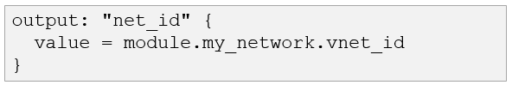
When you run terraform validate, you get the following error:
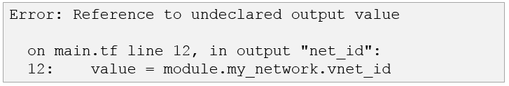
What must you do to successfully retrieve this value from your networking module?
- Define the attribute vnet_id as a variable in the networking module
- Change the referenced value to module.my_network.outputs.vnet_id
- Define the attribute vnet_id as an output in the networking module
- Change the referenced value to my_network.outputs.vnet_id.

Answer 129
Correct Answer: C

Question 130
You are writing a child Terraform module which provisions an AWS instance. You want to make use of the IP address returned in the root configuration. You name the instance resource "main".
Which of these is the correct way to define the output value using HCL2?

- 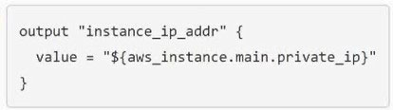
- 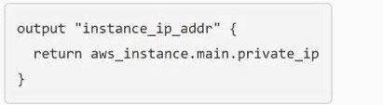

Answer 130
Correct Answer: A
no such definition as "return"

Question 131
How can a ticket-based system slow down infrastructure provisioning and limit the ability to scale? (Choose two.)
- A full audit trail of the request and fulfillment process is generated
- A request must be submitted for infrastructure changes
- As additional resources are required, more tickets are submitted
- A catalog of approved resources can be accessed from drop down lists in a request form.

Answer 131
Correct Answer: BC

Question 132
Which of the following statements about Terraform modules is not true?
- Modules must be publicly accessible.
- Modules can be called multiple times.
- Module is a container for one or more resources.
- Modules can call other modules.

Answer 132
Correct Answer: A
Can be also privately accessible.

Question 133
Which Terraform collection type should you use to store key/value pairs?
- tuple
- set
- map
- list

Answer 133
Correct Answer: C

Question 134
You have used Terraform to create an ephemeral development environment in the cloud and are now ready to destroy all the infrastructure described by your Terraform configuration. To be safe, you would like to first see all the infrastructure that will be deleted by Terraform.
Which command should you use to show all of the resources that will be deleted? (Choose two.)
- Run terraform plan -destroy.
- Run terraform show -destroy.
- Run terraform destroy and it will first output all the resources that will be deleted before prompting for approval.
- Run terraform show -destroy.

Answer 134
Correct Answer: AC

Question 135
When do you need to explicitly execute terraform refresh?
- Before every terraform plan
- Before every terraform apply
- Before every terraform import
- None of the above.

Answer 135
Correct Answer: D

Question 136
All Terraform Cloud tiers support team management and governance.
- True
- False

Answer 136
Correct Answer: B
"Cloud Free" does not provide "Team management". In below link, click "Unified workflow management" under "Features" and search the whole page (Ctrl-F) with "Team management".
Reference: https://www.hashicorp.com/products/terraform/pricing

Question 137
What advantage does an operations team that uses infrastructure as code have?
- The ability to delete infrastructure.
- The ability to update existing infrastructure.
- The ability to reuse best practice configurations and settings.
- The ability to autoscale a group of servers.

Answer 137
Correct Answer: C

Question 138
You have modified your Terraform configuration to fix a typo in the Terraform ID of a resource from aws_security_group.htp to aws_security_group.http
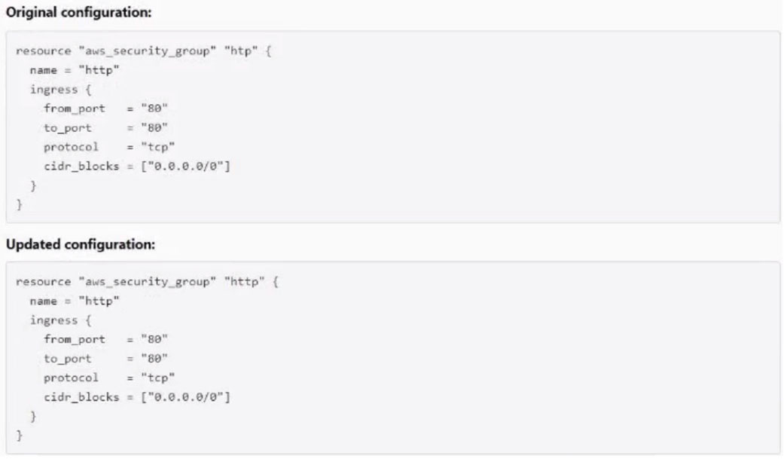
Which of the following commands would you run to update the ID in state without destroying the resource?
- Terraform state mv aws_security_group.htp aws_security_group.http
- terraform apply
- terraform refresh.

Answer 138
Correct Answer: A

Question 139
You are creating a Terraform configuration which needs to make use of multiple providers, one for AWS and one for Datadog.
Which of the following provider blocks would allow you to do this?
- 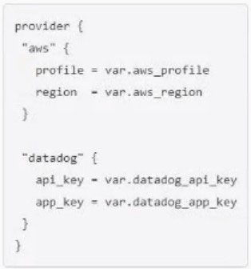
- 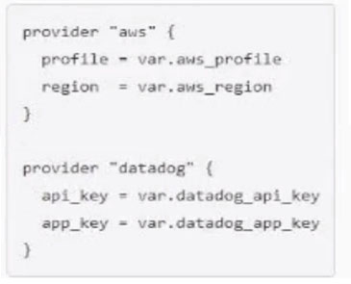
- 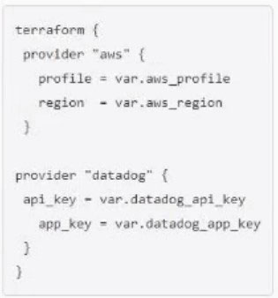

Answer 139
Correct Answer: B
Reference https://www.terraform.io/language/providers/configuration

Question 140
Terraform variable names are saved in the state file.
- True
- False

Answer 140
Correct Answer: B

Question 141
Terraform Cloud is available only as a paid offering from HashiCorp.
- True
- False

Answer 141
Correct Answer: B

Question 142
Which of the following is not a way to trigger terraform destroy?
- Using the destroy command with auto-approve.
- Running terraform destroy from the correct directory and then typing "yes" when prompted in the CLI.
- Passing --destroy at the end of a plan request.
- Delete the state file and run terraform apply.

Answer 142
Correct Answer: C (D)

Question 143
Which of the following is not an advantage of using infrastructure as code operations?
- Self-service infrastructure deployment
- Troubleshoot via a Linux diff command.
- Public cloud console configuration workflows
- Modify a count parameter to scale resources.
- API driven workflows.

Answer 143
Correct Answer: B

Question 144
You're writing a Terraform configuration that needs to read input from a local file called id_rsa.pub.
Which built-in Terraform function can you use to import the file's contents as a string?
- fileset("id_rsa.pub")
- filebase64("id_rsa.pub")
- templatefile("id_rsa.pub")
- file("id_rsa.pub").

Answer 144
Correct Answer: D

Question 145
What does Terraform use providers for? (Choose three.)
- Provision resources for on-premises infrastructure services
- Simplify API interactions.
- Provision resources for public cloud infrastructure services
- Enforce security and compliance policies.
- Group a collection of Terraform configuration files that map to a single state file.

Answer 145
Correct Answer: ABC

Question 146
You can reference a resource created with for_each using a Splat (*) expression.
- True
- False

Answer 146
Correct Answer: B
“A resource”. Only one can’t be referenced by Splat.

Question 147
How does Terraform determine dependencies between resources?
- Terraform automatically builds a resource graph based on resources, provisioners, special meta-parameters, and the state file, if present.
- Terraform requires all dependencies between resources to be specified using the depends_on parameter.
- Terraform requires resources in a configuration to be listed in the order they will be created to determine dependencies.
- Terraform requires resource dependencies to be defined as modules and sourced in order.

Answer 147
Correct Answer: A

Question 148
Which parameters does terraform import require? (Choose two.)
- Path
- Provider
- Resource ID
- Resource address.

Answer 148
Correct Answer: CD

Question 149
Once a new Terraform backend is configured with a Terraform code block, which command(s) is (are) used to migrate the state file?
- terraform apply.
- terraform push.
- terraform destroy, then terraform apply.
- terraform init.

Answer 149
Correct Answer: D

Question 150
What does this code do?
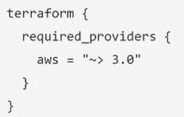
- Requires any version of the AWS provider >= 3.0 and < 4.0
- Requires any version of the AWS provider >= 3.0
- Requires any version of the AWS provider after the 3.0 major release, like 4.1.
- Requires any version of the AWS provider > 3.0.

Answer 150
Correct Answer: A

Question 151
What does terraform refresh modify?
- Your cloud infrastructure
- Your state file
- Your Terraform plan.
- Your Terraform configuration.

Answer 151
Correct Answer: B

Question 152
Which of the following is not valid source path for specifying a module?
- source = "./modulelversion=v1.0.0"
- source = "github.com/hashicorp/example?ref=v1.0.0"
- source = "./module"
- source = "hashicorp/consul/aws".

Answer 152
Correct Answer: A

Question 153
Which of the following is true about terraform apply? (Choose two.)
- It only operates on infrastructure defined in the current working directory or workspace.
- You must pass the output of a terraform plan command to it.
- Depending on provider specification, Terraform may need to destroy and recreate your infrastructure resources.
- By default, it does not refresh your state file to reflect current infrastructure configuration.
- You cannot target specific resources for the operation.

Answer 153
Correct Answer: AC

Question 154
Which of the following statements about local modules is incorrect?
- Local modules are not cached by terraform init command.
- Local modules are sourced from a directory on disk.
- Local modules support versions.
- All of the above (all statements above are incorrect)
- None of the above (all statements above are correct).

Answer 154
Correct Answer: C

Question 155
Which of the following is true about Terraform's implementation of infrastructure as code? (Choose two.)
- It is only compatible with AWS infrastructure management
- You cannot reuse infrastructure configuration
- You can version your infrastructure configuration
- It requires manual configuration of infrastructure resources
- It allows you to automate infrastructure provisioning.

Answer 155
Correct Answer: CE

Question 156
You need to write some Terraform code that adds 42 firewall rules to a security group as shown in the example.
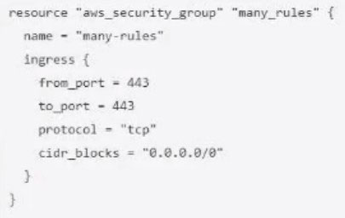
What can you use to avoid writing 42 different nested ingress config blocks by hand?
- A count loop
- A for block
- A for each block
- A dynamic block.

Answer 156
Correct Answer: D
Reference https://awstip.com/terraform-for-vs-for-each-7ff8506a1f94

Question 157
Which of the following is the safest way to inject sensitive values into a Terraform Cloud workspace?
- Write the value to a file and specify the file with the -var-file flag
- Set a value for the variable in the UI and check the "Sensitive" check box
- Edit the state file directly just before running terraform apply
- Set the variable value on the command line with the -var flag.

Answer 157
Correct Answer: B

Question 158
terraform apply will fail if you have not a terraform plan first to update the plan output.
- True
- False.

Answer 158
Correct Answer: B

Question 159
How would you reference the attribute "name" of this fictitious resource in HCL?
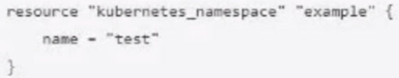
- resource.kubernetes_namespace.example.name
- kubernetes_namespace.test.name
- kubernetes_namespace.example.name
- data.kubernetes_namespace.name
- None of the above.

Answer 159
Correct Answer: C

Question 160
A Terraform output that sets the "sensitive" argument to true will not store that value in the state file.
- True
- False.

Answer 160
Correct Answer: B

Question 161
Which are forbidden actions when the Terraform state file is locked? (Choose three.)
- terraform destroy
- terraform fmt
- terraform state list
- terraform apply
- terraform plan
- terraform validate

Answer 161
Correct Answer: ADE

Question 162
Terraform installs its providers during which phase?
- Plan
- Init
- Refresh
- All of the above.

Answer 162
Correct Answer: B

Question 163
When does Sentinel enforce policy logic during a Terraform Enterprise run?
- Before the plan phase
- During the plan phase
- Before the apply phase
- After the apply phase.

Answer 163
Correct Answer: C
Enforcing policy checks on runs - Policies are checked when a run is performed, after the terraform plan but before it can be confirmed or the terraform apply is executed.

Question 164
What is the purpose of a Terraform workspace in either open source or enterprise?
- Workspaces allow you to manage collections of infrastructure in state files
- A logical separation of business units
- A method of grouping multiple infrastructure security policies
- Provides limited access to a cloud environment.

Answer 164
Correct Answer: A

Question 165
Which is the best way to specify a tag of v1.0.0 when referencing a module stored in Git (for example git::https://example.com/vpc.git)?
- Append ?ref=v1. 0. 0 argument to the source path
- Add version = "1.0.0" parameter to module block
- Nothing: modules stored on GitHub always default to version 1.0.0
- Modules stored on GitHub do not support versioning.

Answer 165
Correct Answer: A
source = "git::https://example.com/vpc.git?ref=v1.2.0"

Question 166
Changing the Terraform backend from the default "local" backend to a different one after doing your first terraform apply is:
- Mandatory
- Optional
- Impossible
- Discouraged

Answer 166
Correct Answer: B

Question 167
You have modified your local Terraform configuration and ran terraform plan to review the changes. Simultaneously, your teammate manually modified the infrastructure component you are working on. Since you already ran terraform plan locally, the execution plan for terraform apply will be the same.
- True
- False

Answer 167
Correct Answer: B

Question 168
terraform apply is failing with the following error. What next step should you take to determine the root cause of the problem?
Error loading state: AccessDenied: Access Denied status code: 403, request id: 288766CE5CCA24A0, host id: FOOBAR
- Set TF_LOG=DEBUG
- Review syslog for Terraform error messages
- Run terraform login to reauthenticate with the provider
- Review /var/log/terraform.log for error messages.

Answer 168
Correct Answer: A
You can set TF_LOG to one of the log levels (in order of decreasing verbosity) TRACE, DEBUG, INFO, WARN or ERROR to change the verbosity of the log

Question 169
As a member of an operations team that uses infrastructure as code (IaC) practices, you are tasked with making a change to an infrastructure stack running in a public cloud.
Which pattern would follow IaC best practices for making a change?
- Clone the repository containing your infrastructure code and then run the code.
- Use the public cloud console to make the change after a database record has been approved.
- Make the change programmatically via the public cloud CLI.
- Make the change via the public cloud API endpoint.
- Submit a pull request and wait for an approved merge of the proposed changes.

Answer 169
Correct Answer: E

Question 170
What command can you run to generate DOT (Document Template) formatted data to visualize Terraform dependencies?
- terraform refresh
- terraform show
- terraform graph
- terraform output

Answer 170
Correct Answer: C

Question 171
Which provider authentication method prevents credentials from being stored in the state file?
- Using environment variables
- Specifying the login credentials in the provider block
- Setting credentials as Terraform variables
- None of the above.

Answer 171
Correct Answer: A

Question 172
Running terraform fmt without any flags in a directory with Terraform configuration files will check the formatting of those files without changing their contents.
- True
- False

Answer 172
Correct Answer: B

Question 173
terraform init retrieves the source code for all referenced modules.
- True
- False.

Answer 173
Correct Answer: A
Reference https://www.terraform.io/cli/commands/init

Question 174
You have a Terraform configuration that defines a single virtual machine with no references to it. You have run terraform apply to create the resource, and then removed the resource definition from your Terraform configuration file.
What will happen when you run terraform apply in the working directory again?
- Nothing
- Terraform will destroy the virtual machine.
- Terraform will error.
- Terraform will remove the virtual machine from the state file, but the resource will still exist.

Answer 174
Correct Answer: B

Question 175
Which configuration consistency errors does terraform validate report?
- A mix of spaces and tabs in configuration files
- Differences between local and remote state
- Terraform module isn't the latest version.
- Declaring a resource identifier more than once.

Answer 175
Correct Answer: D

Question 177
Where can Terraform not load a provider from?
- Source code
- Plugins directory
- Official HashiCorp distribution on releases.hashicorp.com
- Provider plugin cache.

Answer 177
Correct Answer: A
- no info about TF loading a provider directly from source code, so this must be the correct answer.
- In the plugin directory are stored the providers, so TF could load providers from it.
- releases.hashicorp.com is a valid source where providers can be downloaded from.
- If the plugin provider cache is enabled eventually a provider could be loaded from it.

Question 178
Which of the following locations can Terraform use as a private source for modules? (Choose two.)
- Internally hosted SCM (Source Control Manager) platform
- Public Terraform Module Registry
- Private repository on GitHub
- Public repository on GitHub.

Answer 178
Correct Answer: AC

Question 179
Why should secrets not be hard coded into Terraform code? (Choose two.)
- It makes the code less reusable.
- Terraform code is typically stored in version control, as well as copied to the systems from which it's run. Any of those may not have robust security mechanisms.
- The Terraform code is copied to the target resources to be applied locally and could expose secrets if a target resource is compromised.
- All passwords should be rotated on a quarterly basis.

Answer 179
Correct Answer: AB
AB, terraform code will not be copied to target resource, only to runners; if you deploy a VM the code will not copied to the VM

Question 180
If a Terraform creation-time provisioner fails, what will occur by default?
- The resource will not be affected, but the provisioner will need to be applied again.
- The resource will be destroyed.
- The resource will be marked as "tainted."
- Nothing, provisioners will not show errors in the command line.

Answer 180
Correct Answer: C
Reference
https://www.terraform.io/language/resources/provisioners/syntax#creation-time-provisioner

Question 181
When should Terraform configuration files be written when running terraform import on existing infrastructure?
- Infrastructure can be imported without corresponding Terraform code.
- Terraform will generate the corresponding configuration files for you.
- You should write Terraform configuration files after the next terraform import is executed.
- Terraform configuration should be written before terraform import is executed.

Answer 181
Correct Answer: D
The current implementation of Terraform import can only import resources into the state. It does not generate configuration. A future version of Terraform will also generate configuration.
Because of this, prior to running terraform import it is necessary to write manually a resource configuration block for the resource, to which the imported object will be mapped.
Reference https://www.terraform.io/cli/import

Question 182
Which command lets you experiment with Terraform's built-in functions?
- terraform env
- terraform console
- terraform test
- terraform validate

Answer 182
Correct Answer: B
Reference https://www.terraform.io/language/functions

Question 183
Why does this backend configuration not follow best practices?.
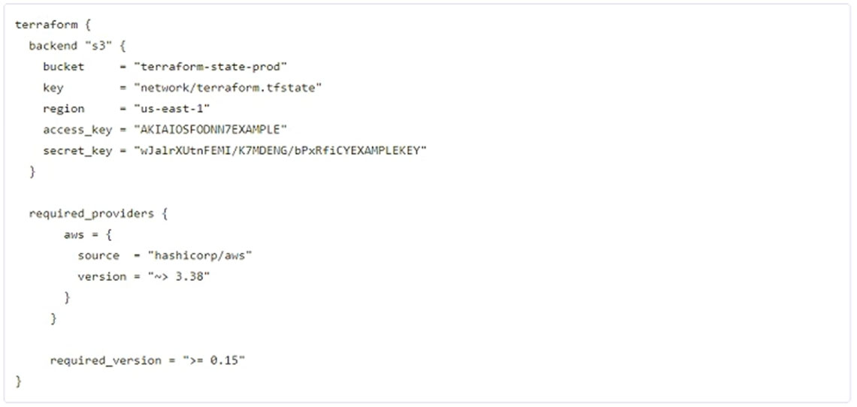
- You should not store credentials in Terraform Configuration
- You should use the local enhanced storage backend whenever possible
- An alias meta-argument should be included in backend blocks whenever possible
- The backend configuration should contain multiple credentials so that more than one user can execute terraform plan and terraform apply

Answer 183
Correct Answer: A

Question 184
Open source Terraform can only import publicly-accessible and open-source modules.
- True
- False.

Answer 184
Correct Answer: B
Reference https://www.terraform.io/language/modules

Question 185
What does terraform destroy do?
- Destroy all infrastructure in the Terraform state file.
- Destroy all Terraform code files in the current directory while leaving the state file intact.
- Destroy all infrastructure in the configured Terraform provider.
- Destroy the Terraform state file while leaving infrastructure intact.

Answer 185
Correct Answer: A
Reference https://learn.hashicorp.com/tutorials/terraform/aws-destroy

Question 186
While attempting to deploy resources into your cloud provider using Terraform, you begin to see some odd behavior and experience sluggish responses. In order to troubleshoot you decide to turn on Terraform debugging. Which environment variables must be configured to make Terraform's logging more verbose?
- TF_LOG_LEVEL
- TF_LOG_FILE
- TF_LOG
- TP_LOG_PATH.

Answer 186
Correct Answer: C
Reference https://www.terraform.io/internals/debugging

Question 187
If a DevOps team adopts AWS CloudFormation as their standardized method for provisioning public cloud resources, which of the following scenarios poses a challenge for this team?
- The team is asked to build a reusable code base that can deploy resources into any AWS region.
- The team is asked to manage a new application stack built on AWS-native services.
- The organization decides to expand into Azure and wishes to deploy new infrastructure using their existing codebase.
- The DevOps team is tasked with automating a manual provisioning process.

Answer 187
Correct Answer: C
Reference https://developer.hashicorp.com/terraform/intro/vs/cloudformation

Question 188
You cannot install third party plugins using terraform init.
- True
- False.

Answer 188
Correct Answer: B

Question 189
Which of the following can you do with terraform plan? (Choose two.)
- Save a generated execution plan to apply later.
- Execute a plan in a different workspace.
- View the execution plan and check if the changes match your expectations.
- Schedule Terraform to run at a planned time in the future.

Answer 189
Correct Answer: AC
Reference https://learn.hashicorp.com/tutorials/terraform/plan

Question 190
Which are examples of infrastructure as code? (Choose two.)
- Cloned virtual machine images.
- Change management database records.
- Versioned configuration files
- Docker files.

Answer 190
Correct Answer: CD

Question 191
FILL BLANK -
You need to migrate a workspace to use a remote backend. After updating your configuration, what command do you run to perform the migration?
Type your answer in the field provided. The text field is not case-sensitive and all variations of the correct answer are accepted.

Answer 191
Correct Answer: terraform init
Reference https://developer.hashicorp.com/terraform/cli/commands/init

Question 192
When using a module from the public Terraform Module Registry, the following parameters are required attributes in the module block. (Choose two.)
- Each of the module’s required inputs
- The module’s source address
- Terraform Module Registry account token.
- Each of the module’s dependencies (example: submodules)
- The version of the module.

Answer 192
Correct Answer: AB
Reference https://developer.hashicorp.com/terraform/language/modules/syntax

Question 193
As a developer, you want to ensure your plugins are up to date with the latest versions. Which Terraform command should you use?
- terraform init -upgrade.
- terraform apply -upgrade.
- terraform refresh -upgrade.
- terraform providers -upgrade.

Answer 193
Correct Answer: A

Question 194
You can access state stored with the local backend by using the terraform_remote_state data source.
- True
- False.

Answer 194
Correct Answer: B
The terraform_remote_state data source is used to fetch outputs from the state of a different Terraform configuration, which is stored remotely, and use them as input for the current configuration. It is used with remote backends, not local ones.

Question 195
You have been working in a Cloud provider account that is shared with other team members. You previously used Terraform to create a load balancer that is listening on port 80. After some application changes, you updated the Terraform code to change the port to 443.
You run terraform plan and see that the execution plan shows the port changing from 80 to 443 like you intended, and step away to grab some coffee.
In the meantime, another team member manually changes the load balancer port to 443 through the Cloud provider console before you get back to your desk.
What will happen when you terraform apply upon returning to your desk?
- Terraform will fail with an error because the state file is no longer accurate.
- Terraform will change the load balancer port to 80, and then change it back to 443.
- Terraform will not make any changes to the Load Balancer and will update the state file to reflect any changes made.
- Terraform will change the port back to 80 in your code.

Answer 195
Correct Answer: C

Question 196
In a Terraform Cloud workspace linked to a version control repository, speculative plan runs start automatically when you merge or commit changes to version control.
- True
- False.

Answer 196
Correct Answer: A
Reference https://developer.hashicorp.com/terraform/cloud-docs/workspaces/settings/vcs

Question 197
You have some Terraform code and a variable definitions file named dev.auto.tfvars that you tested successfully in the dev environment. You want to deploy the same code in the staging environment with a separate variable definition file and a separate state file.
Which two actions should you perform? (Choose two.)
- Copy the existing terraform.tfstate file and save it as staging.terraform.tfstate
- Write a new staging.auto.tfvars variable definition file and run Terraform with the var-file=”staging.auto.tfvars” flag
- Create a new Terraform workspace for staging.
- Create a new Terraform provider for staging.
- Add new Terraform code (*.tf files) for staging in the same directory.

Answer 197
Correct Answer: BC

Question 198
The ________ determines how Terraform creates, updates, or deletes resources.
- Terraform configuration.
- Terraform core.
- Terraform provider.
- Terraform provisioner.

Answer 198
Correct Answer: C
provider = how, .tf = what

Question 199
Terraform destroy is the only way to remove infrastructure.
- True
- False.

Answer 199
Correct Answer: B

Question 200
Which of the following is the correct way to pass the value in the variable num_servers into a module with the input servers in HCL2?
- servers = var.num_servers
- servers = num_servers
- servers = var(num_servers)
- $(var.num_servers).

Answer 200
Correct Answer: A

Question 201
Which of the fallowing commands would you use to access all of the attributes and details of a resource managed by Terraform?
- terraform state list
- terraform state show
- terraform get
- terraform state list.

Answer 201
Correct Answer: B
Reference https://developer.hashicorp.com/terraform/cli/commands/state/show

Question 202
How would you be able to reference an attribute from the vsphere_datacenter data source for use with the datacenter_id argument within the vsphere_folder resource in the following configuration?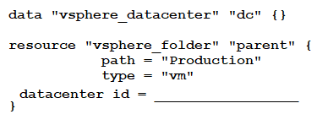
- data.dc.id
- data.vsphere_datacenter.dc
- vsphere_datacenter.dc.id
- data.vsphere_datacenter.dc.id.

Answer 202
Correct Answer: D

Question 203
You decide to move a Terraform state file to Amazon S3 from another location. You write the code below into a file called backend.tf.
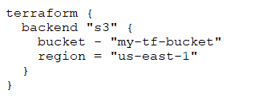
Which command will migrate your current state file to the new S3 remote backend?
- terraform state.
- terraform init.
- terraform refresh.
- terraform push.

Answer 203
Correct Answer: B

Question 204
You want to tag multiple resources with a string that is a combination of a generated random_id and a variable.
How should you use the same value in all these resources without repeating the random_id and variable in each resource?
- Local values
- Data source
- Modules
- Outputs.

Answer 204
Correct Answer: A

Question 205
Which of the following is not a benefit of adopting infrastructure as code?
- Interpolation
- Reusability of code
- Versioning
- Automation.

Answer 205
Correct Answer: A

Question 206
Module version is required to reference a module on the Terraform Module Registry.
- True
- False

Answer 206
Correct Answer: B
Specifying a versions is not mandatory. When a version is not specified, Terraform just downloads the latest version

Question 207
While deploying a virtual machine, the first launch user_data script fails due to race condition with another resource deployed during the same Terraform run.
What is the least disruptive method to correct the issue?
- Run terraform taint against the virtual machine’s resource name, then terraform apply.
- Restart the virtual machine from the cloud portal.
- Run terraform apply again.
- Run terraform destroy then terraform apply.

Answer 207
Correct Answer: A
Reference https://developer.hashicorp.com/terraform/language/resources/provisioners/syntax

Question 208
The public Module Registry is free to use.
- True
- False.

Answer 208
Correct Answer: A

Question 209
Both Terraform Cloud and Terraform Enterprise support policy as code (Sentinel).
- True
- False

Answer 209
Correct Answer: A

Question 210
You want to define multiple data disks as nested blocks inside the resource block for a virtual machine.
What Terraform feature would help you define the blocks using the values in a variable?
- Local values
- Collection functions
- Dynamic blocks
- Count arguments.

Answer 210
Correct Answer: C

Question 211
Which of the following module source paths does not specify a remote module?
- source = “./modules/consul”
- source = “git@github.com:hashicorp/example.git”
- source = “github.com/hashicorp/example”
- source = “hashicorp/consul/aws.

Answer 211
Correct Answer: A
since its local path and question says "remote".

Question 212
You have a list of numbers that represents the number of free CPU cores on each virtual cluster:
numcpus = [ 18, 3, 7, 11, 2 ]
What Terraform function could you use to select the largest number from the list?
- max(numcpus)
- ceil(numcpus)
- top(numcpus)
- high[numcpus]

Answer 212
Correct Answer: A
Reference https://developer.hashicorp.com/terraform/language/functions/

Question 213
Variables declared within a module are accessible outside of the module.
- True
- False.

Answer 213
Correct Answer: B

Question 214
Which of the following is not a valid Terraform variable type?
- list
- map
- array
- string

Answer 214
Correct Answer: C

Question 215
What is a key benefit of the Terraform state file?
- A state file can be used to schedule recurring infrastructure tasks.
- A state file represents a source of truth for resources provisioned with a public cloud console.
- A state file represents the desired state expressed by the Terraform code files.
- A state file represents a source of truth for resources provisioned with Terraform.

Answer 215
Correct Answer: D
A key benefit of the Terraform state file is that it represents a source of truth for resources provisioned with Terraform. The state file is used to keep track of the current state of the infrastructure resources that are being managed by Terraform. It contains information about the resources, their properties, and the dependencies between them.
The state file is used by Terraform to determine what changes need to be made to the infrastructure to reach the desired state defined in the configuration files.

Question 216
Which of these statements about Terraform Enterprise workspaces is false?
- They can securely store cloud credentials.
- You must use the CLI to switch between workspaces.
- Plans and applies can be triggered via version control system integrations.
- They have role-based access controls.

Answer 216
Correct Answer: B
Terraform Enterprise provides a web-based UI that allows you to switch between workspaces, view the state of your infrastructure, and run Terraform commands without having to use the command line interface.

Question 217
Define the purpose of state in Terraform.
- State is used to map real world resources to your configuration and keep track of metadata
- State is a method of codifying the dependencies of related resources
- State is used to enforce resource configurations that relate to compliance policies
- State is used to store variables and quickly reuse existing code.

Answer 217
Correct Answer: A

Question 218
Which backend does the Terraform CLI use by default?
- API
- Remote
- Terraform Cloud
- Local
- HTTP

Answer 218
Correct Answer: D

Question 219
Using the terraform state rm command against a resource will destroy it.
- True
- False

Answer 219
Correct Answer: B

Question 220
Which method for sharing Terraform configurations keeps them confidential within your organization, supports Terraform’s semantic version constraints, and provides a browsable directory?
- Generic git repository
- Terraform Cloud/Terraform Enterprise private module registry
- Public Terraform Module Registry
- Subfolder within a workspace.

Answer 220
Correct Answer: B
The Terraform Cloud/Terraform Enterprise private module registry allows organizations to store and share Terraform configurations in a private and secure way. This method keeps the configurations confidential within your organization, supports Terraform's semantic version constraints, and provides a browsable directory.

Question 221
You are writing a child Terraform module which provisions an AWS instance. You want to make use of the IP address returned in the root configuration. You name the instance resource “main”.
Which of these is the correct way to define the output value using HCL2?

- 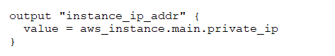
- 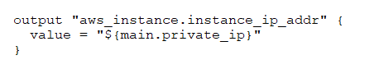
C. 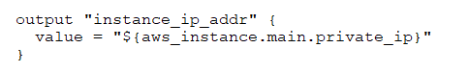
D. 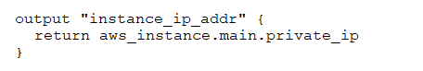

Answer 221
Correct Answer: A
C is not valid because the quotes.

Question 222
How would you refer to the indexing instance from the below configuration?
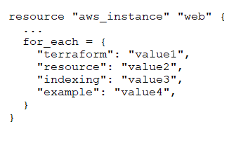
- aws_instance[“web”][“indexing”]
- aws_instance.web.indexing
- aws_instance-web[“indexing”]
- aws_instance.web[“indexing”]

Answer 222
Correct Answer: D

Question 223
Which feature is not included in Terraform Cloud’s free tier?
- Workspace
- Remote state management
- Audit logging
- Private module registry

Answer 223
Correct Answer: C
Reference https://www.hashicorp.com/products/terraform/pricing

Question 224
When should you run terraform init?
- After you run terraform apply for the first time in a new Terraform project and before you run terraform plan
- After you run terraform plan for the first time in a new Terraform project and before you run terraform apply
- After you start coding a new Terraform project and before you run terraform plan for the first time
- Before you start coding a new Terraform project

Answer 224
Correct Answer: C

Question 225
Terraform configuration (including any module references) can contain only one Terraform provider type.
- True
- False

Answer 225
Correct Answer: A(B)
“Can” indicates that could be one or many so the answer is “A.” If the question is “must”, then the answer is “B.”

Question 226
You are making changes to existing Terraform code to add some new infrastructure.
When is the best time to run terraform validate?
- After you run terraform plan so you can validate that your state file is consistent with your infrastructure
- Before you run terraform plan so you can validate your code syntax
- Before you run terraform apply so you can validate your infrastructure changes
- After you run terraform apply so you can validate that your infrastructure is reflected in your code

Answer 226
Correct Answer: B

Question 227
How does Terraform manage most dependencies between resources?
- By defining dependencies as modules and including them in a particular order
- The order that resources appear in Terraform configuration indicates dependencies
- Using the depends_on parameter
- Terraform will automatically manage most resource dependencies

Answer 227
Correct Answer: D

Question 228
What does running a terraform plan do?
- Imports all of your existing cloud provider resources to the state file
- Compares the state file to your Terraform code and determines if any changes need to be made
- Imports all of your existing cloud provider resources to your Terraform configuration file
- Compares your Terraform code and local state file to the remote state file in a cloud provider and determines if any changes need to be made

Answer 228
Correct Answer: B

Question 229
What are some benefits of using Sentinel with Terraform Cloud/Terraform Enterprise? (Choose three.)
- Policy-as-code can enforce security best practices
- You can restrict specific configurations on resources like "CIDR=0.0.0.0/0" not allowed
- You can enforce a list of approved AWS AMIs
- Sentinel Policies can be written in HashiCorp Configuration Language (HCL)
- You can check out and check in cloud access keys

Answer 229
Correct Answer: ABC
Sentinel is a policy-as-code framework that integrates with Terraform Cloud and Terraform Enterprise, allowing you to enforce policies on your infrastructure as part of the provisioning process. By using Sentinel, you can enforce security best practices, restrict specific configurations such as disallowing overly permissive CIDR blocks, and maintain a list of approved AWS AMIs, among other things. This helps to ensure that your infrastructure is secure, compliant, and adheres to organizational standards.

Question 230
You want to share Terraform state with your team, store it securely, and provide state locking.
How would you do this? (Choose three.)
- Using the remote Terraform backend with Terraform Cloud / Terraform Enterprise.
- Using the local backend.
- Using the s3 terraform backend. The dynamodb_field option is not needed.
- Using an s3 terraform backend with an appropriate IAM policy and dynamodb_field option configured.
- Using the consul Terraform backend.

Answer 230
Correct Answer: ADE
Dynamodb_field acts as “lease” on Azure Storage.
Reference: https://developer.hashicorp.com/terraform/language/settings/backends/s3 flag needs to be enabled

Question 231
From which of these sources can Terraform import modules?
- Local path
- GitHub Repository
- Terraform Module Registry
- All of the above

Answer 231
Correct Answer: D

Question 232
How would you output returned values from a child module?
- Declare the output in the root configuration
- Declare the output in the child module
- Declare the output in both the root and child module
- None of the above

Answer 232
Correct Answer: B
In Terraform, it is not necessary to declare an output in both the root and child module. The output declared in the child module will be available to the root module, so you only need to declare an output in the root module if you want to expose that value to the outside world or use it in another module.
If you declare an output in both the root and child module with the same name, Terraform will use the output from the root module as the final output. This can be useful if you want to override the output value of the child module with a different value in the root module.
However, it is generally a good practice to avoid duplicate output names between modules to prevent confusion and ensure that the output values are clearly defined and organized.
In summary, it is not necessary to declare an output in both the root and child module, but if you do, the output from the root module will override the output from the child module. It is recommended to use unique output names to avoid confusion and ensure clear organization of output values

Question 233
You have decided to create a new Terraform workspace to deploy a development environment.
What is different about this workspace?
- It has its own state file
- It pulls in a different terraform.tfvars file
- It uses a different branch of code
- It uses a different backend

Answer 233
Correct Answer: A

Question 234
Any user can publish modules to the public Terraform Module Registry.
- True
- False

Answer 234
Correct Answer: A

Question 235
Which of these commands makes your code more human readable?
- terraform validate
- terraform output
- terraform plan
- terraform fmt

Answer 235
Correct Answer: D

Question 236
Infrastructure as Code (IaC) can be stored in a version control system along with application code.
- True
- False

Answer 236
Correct Answer: A

Question 237
Select the command that doesn’t cause Terraform to refresh its state.
- terraform apply
- terraform destroy
- terraform plan
- terraform state list

Answer 237
Correct Answer: D

Question 238
Sentinel policy-as-code is available in Terraform Enterprise.
- True
- False

Answer 238
Correct Answer: A
Reference https://docs.hashicorp.com/sentinel/terraform

Question 239
Before you can use Terraform’s remote backend, you must first execute terraform init.
- True
- False

Answer 239
Correct Answer: A
You can configure remote backend without init, but you can’t use it.

Question 240
Which two steps are required to provision new infrastructure in the Terraform workflow? (Choose two.)
- Plan
- Apply
- Import
- Init
- Validate

Answer 240
Correct Answer: BD

Question 241
You are working on some new application features and you want to spin up a copy of your production deployment to perform some quick tests. In order to avoid having to configure a new state backend, what open source Terraform feature would allow you create multiple states but still be associated with your current code?
- Terraform data sources
- Terraform local values
- Terraform modules
- Terraform workspaces
- None of the above

Answer 241
Correct Answer: D

Question 242
Which provisioner invokes a process on the machine running Terraform?
- remote-exec
- file
- local-exec
- null-exec

Answer 242
Correct Answer: C
Reference https://developer.hashicorp.com/terraform/language/resources/provisioners/local-exec

Question 243
____________ backends support state locking.
- Some
- No
- Only local
- All

Answer 243
Correct Answer: A

Question 244
Which of the following methods, used to provision resources into a public cloud, demonstrates the concept of infrastructure as code?
- curl commands manually run from a terminal
- A sequence of REST requests you pass to a public cloud API endpoint
- A script that contains a series of public cloud CLI commands
- A series of commands you enter into a public cloud console

Answer 244
Correct Answer: C

Question 245
Which of the following should you put into the required_providers block?
- version >= 3.1
- version = “>= 3.1”
- version ~> 3.1

Answer 245
Correct Answer: B

Question 246
When should you write Terraform configuration files for existing infrastructure that you want to start managing with Terraform?
- Before you run terraform import
- You can import infrastructure without corresponding Terraform code
- Terraform will generate the corresponding configuration files for you
- After you run terraform import

Answer 246
Correct Answer: A

Question 247
Which command should you run to check if all code in a Terraform configuration that references multiple modules is properly formatted without making changes?
- terraform fmt -write=false
- terraform fmt -list -recursive
- terraform fmt -check -recursive
- terraform fmt -check

Answer 247
Correct Answer: C

Question 248
What features stops multiple users from operating on the Terraform state at the same time?
- Provider constraints
- Remote backends
- State locking
- Version control

Answer 248
Correct Answer: C

Question 249
You are creating a reusable Terraform configuration and want to include a billing_dept tag so your Finance team can track team-specific spending on resources. Which of the following billing_dept variable declarations will allow you to do this?
- 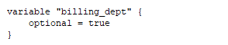
- 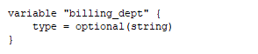
- 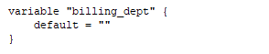
- 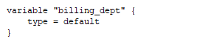

Answer 249
Correct Answer: C

Question 250
Which of these are secure options for storing secrets for connecting to a Terraform remote backend? (Choose two.)
- Inside the backend block within the Terraform configuration
- Defined in Environment variables
- Defined in a connection configuration outside of Terraform
- A variable file

Answer 250
Correct Answer: BC

Question 251
You want to define a single input variable to capture configuration values for a server. The values must represent memory as a number, and the server name as a string.
Which variable type could you use for this input?
- List
- Object
- Map
- Terraform does not support complex input variables of different types

Answer 251
Correct Answer: B

Question 252
What does Terraform not reference when running a terraform apply -refresh-only?
- Credentials
- State file
- Terraform resource definitions in configuration files
- Cloud provider

Answer 252
Correct Answer: C

Question 253
Multiple team members are collaborating on infrastructure using Terraform and want to format their Terraform code following standard Terraform-style convention. How could they automatically ensure the code satisfies conventions?
- Run the terraform fmt command during the code linting phase of your CI/CD process
- Manually apply two spaces indentation and align equal sign "=" characters in every Terraform file (*.tf)
- Run the terraform validate command prior to executing terraform plan or terraform apply

Answer 253
Correct Answer: A

Question 254
When using a remote backend or Terraform Cloud integration, where does Terraform save resource state?
- On the disk
- In memory
- In an environment variable
- In the remote backend or Terraform Cloud

Answer 254
Correct Answer: D

Question 255
In Terraform HCL, an object type of object({ name=string, age=number }) would match this value:
- 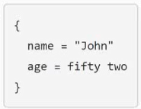
- 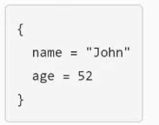
- 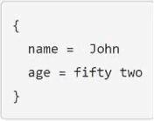
- 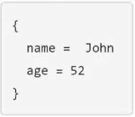

Answer 255
Correct Answer: B

Question 256
You add a new resource to an existing Terraform configuration, but do not update the version constraint in the configuration. The existing and new resources use the same provider. The working directory contains a .terraform-lock.hcl file.
How will Terraform choose which version of the provider to use?
- Terraform will use the latest version of the provider for the new resource and the version recorded in the lock file to manage existing resources
- Terraform will use the version recorded in your lock file
- Terraform will check your state file to determine the provider version to use
- Terraform will use the latest version of the provider available at the time you provision your new resource

Answer 256
Correct Answer: B

Question 257
You must use different Terraform commands depending on the cloud provider you use.
- True
- False

Answer 257
Correct Answer: B

Question 258
Define the purpose of state in Terraform.
- State stores variables and lets you quickly reuse existing code
- State lets you enforce resource configurations that relate to compliance policies
- State codifies the dependencies of related resources
- State maps real world resources to your configuration and keeps track of metadata

Answer 258
Correct Answer: D

Question 259
Which of these actions will prevent two Terraform runs from changing the same state file at the same time?
- Refresh the state after running Terraform
- Delete the state before running Terraform
- Configure state locking for your state backend
- Run Terraform with parallelism set to 1

Answer 259
Correct Answer: C

Question 260
While attempting to deploy resources into your cloud provider using Terraform, you begin to see some odd behavior and experience slow responses. In order to troubleshoot you decide to turn on Terraform debugging. Which environment variables must be configured to make Terraform’s logging more verbose?
- TF_LOG_PATH
- TF_VAR_log_level
- TF_LOG
- TF_VAR_log_path

Answer 260
Correct Answer: C

Question 261
The Terraform binary version and provider versions must match each other in a single configuration.
- True
- False

Answer 261
Correct Answer: B

Question 262
The .terraform.lock.hcl file tracks module versions.
- True
- False

Answer 262
Correct Answer: B
The .terraform.lock.hcl file is not used to track module versions; it is used to lock the versions of the provider dependencies used by your Terraform configuration.
At present, the dependency lock file tracks only provider dependencies. Terraform does not remember version selections for remote modules, and so Terraform will always select the newest available module version that meets the specified version constraints. You can use an exact version constraint to ensure that Terraform will always select the same module version.

Question 263
You can develop a custom provider to manage its resources using Terraform.
- True
- False

Answer 263
Correct Answer: A

Question 264
Which of these is not a benefit of remote state?
- Keeping unencrypted sensitive information off disk
- Easily share reusable code modules
- Working in a team
- Delegate output to other teams

Answer 264
Correct Answer: B

Question 265
When using multiple configurations of the same Terraform provider, what meta-argument must be included in any non-default provider configurations?
- depends_on
- alias
- id
- name

Answer 265
Correct Answer: B

Question 266
A developer accidentally launched a VM (virtual machine) outside of the Terraform workflow and ended up with two servers with the same name. They don’t know which VM Terraform manages but do have a list of all active VM IDs.
Which of the following methods could you use to discover which instance Terraform manages?
- Run terraform taint/code on all the VMs to recreate them
- Update the code to include outputs for the ID of all VMs, then run terraform plan to view the outputs
- Run terraform state list to find the names of all VMs, then run terraform state show for each of them to find which VM ID Terraform manages
- Use terraform refresh/code to find out which IDs are already part of state

Answer 266
Correct Answer: C

Question 267
Which of the following is not considered a safe way to inject sensitive values into a Terraform Cloud workspace?
- Edit the state file directly just before running terraform apply
- Set the variable value on the command line with the -var flag
- Write the value to a file and specify the file with the -var-file flag

Answer 267
Correct Answer: A

Question 268
If you update the version constraint in your Terraform configuration, Terraform will update your lock file the next time you run terraform init.
- True
- False

Answer 268
Correct Answer: B
You will get an error. You have to run terraform init -upgrade to change the version in .terraform.lock.hcl file.

Question 269
You must initialize your working directory before running terraform validate.
- True
- False

Answer 269
Correct Answer: A

Question 270
If you manually destroy infrastructure, what is the best practice reflecting this change in Terraform?
- Manually update the state file
- Remove the resource definition from your file and run terraform apply -refresh-only
- Run terraform import
- It will happen automatically

Answer 270
Correct Answer: B

Question 271
You created infrastructure outside of the Terraform workflow that you now want to manage using Terraform. Which command brings the infrastructure into Terraform state?
- terraform init
- terraform get
- terraform refresh
- terraform import

Answer 271
Correct Answer: D

Question 272
When using Terraform to deploy resources into Azure, which scenarios are true regarding state files?
- When you change a Terraform-managed resource via the Azure Cloud Console, Terraform updates the state file to reflect the change during the next plan or apply
- Changing resources via the Azure Cloud Console records the change in the current state file
- When you change a resource via the Azure Cloud Console, Terraform records the changes in a new state file
- Changing resources via the Azure Cloud Console does not update current state file

Answer 272
Correct Answer: D

Question 273
Which statement describes a goal of infrastructure as code?
- A pipeline process to test and deliver software
- Defining a vendor-agnostic API
- Write once, run anywhere
- The programmatic configuration of resources

Answer 273
Correct Answer: D

Question 274
Terraform validate confirms the syntax of Terraform files.
- True
- False

Answer 274
Correct Answer: A

Question 275
Which command adds existing resources into Terraform state?
- terraform init
- terraform plan
- terraform refresh
- terraform import
- All of these

Answer 275
Correct Answer: D

Question 276
It is best practice to store secret data in the same version control repository as your Terraform configuration.
- True
- False

Answer 276
Correct Answer: B

Question 277
Which of the following commands would you use to access all of the attributes and details of a resource managed by Terraform?
- terraform state list ‘provider_type.name’
- terraform state show ‘provider_type.name’
- terraform get ‘provider_type.name’
- terraform state list

Answer 277
Correct Answer: B

Question 278
terraform validate confirms that your infrastructure matches the Terraform state file.
- True
- False

Answer 278
Correct Answer: B

Question 279
A senior admin accidentally deleted some of your cloud instances. What does Terraform do when you run terraform apply?
- Build a completely brand new set of infrastructure
- Tear down the entire workspace infrastructure and rebuild it
- Rebuild only the instances that were deleted
- Stop and generate an error message about the missing instances.

Answer 279
Correct Answer: C

Question 280
terraform init creates an example main.tf file in the current directory.
- True
- False

Answer 280
Correct Answer: B

Question 281
Which argument helps prevent unexpected updates when calling Terraform Registry modules?
- count
- source
- version
- lifecycle

Answer 281
Correct Answer: C
The version argument helps prevent unexpected updates when calling Terraform Registry modules. It allows you to specify the exact version of the module you want to use. This ensures that your configuration consistently uses the same version of the module until you explicitly decide to update it to a newer version.
Using the version argument is a good practice to ensure that your infrastructure remains stable and predictable, as it prevents unintentional changes caused by automatic module updates.

Question 282
Setting the TF_LOG environment variable to DEBUG causes debug messages to be logged into stdout.
- True
- False

Answer 282
Correct Answer: B
Terraform has detailed logs that you can enable by setting the TF_LOG environment variable to any value. Enabling this setting causes detailed logs to appear on stderr.

Question 283
How would you output returned values from a child module in the Terraform CLI output?
- Declare the output in the root configuration
- Declare the output in the child module
- Declare the output in both the root and child module
- None of the above

Answer 283
Correct Answer: C (B)
Child parent Output CLI

Question 284
What is the Terraform resource name of the following resource block?
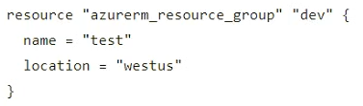
- azurerm_resource_group
- azurerm
- test
- dev

Answer 284
Correct Answer: D

Question 285
When do you need to explicitly execute terraform refresh-only?
- Before every terraform plan
- Before every terraform apply
- Before every terraform import
- None of the above

Answer 285
Correct Answer: D

Question 286
How is the Terraform cloud integration differ from other state backends such as S3, Consul, etc.?
- It can execute Terraform runs on dedicated infrastructure in Terraform Cloud
- It doesn't show the output of a terraform apply locally
- It is only available to paying customers
- All of the above

Answer 286
Correct Answer: A

Question 287
Which of the following are advantages of using infrastructure as code (IaC) instead of provisioning with a graphical user interface (GUI)? (Choose two.)
- Secures your credentials
- Let’s your version, reuse, and share infrastructure configuration
- Provisions the same resources at a lower cost
- Reduces risk of operator error
- Prevents manual modifications to your resources

Answer 287
Correct Answer: BD

Question 288
One cloud configuration always maps to a single remote workspace.
- True
- False

Answer 288
Correct Answer: B

Question 289
Multiple team members are collaborating on infrastructure using Terraform and want to format their Terraform code following standard Terraform-style convention.
How could they automatically ensure the code satisfies conventions?
- Replace all tabs with spaces
- Terraform automatically formats configuration on terraform apply
- Run terraform validate prior to executing terraform plan or terraform apply
- Use terraform fmt

Answer 289
Correct Answer: D

Question 290
Which backend does the Terraform CLI use by default?
- Depends on the cloud provider configured
- Remote
- Terraform Cloud
- Local
- HTTP

Answer 290
Correct Answer: D

Question 291
The Terraform CLI will print output values from a child module after running terraform apply.
- True
- False.

Answer 291
Correct Answer: B
A child module can use outputs to expose a subset of its resource attributes to a parent module.
A root module can use outputs to print certain values in the CLI output after running terraform apply.

Question 292
What does terraform refresh-only modify?
- Your cloud infrastructure
- Your Terraform plan
- Your Terraform configuration
- Your state file

Answer 292
Correct Answer: D

Question 293
What does terraform import do?
- Imports existing resources into the state file
- Imports all infrastructure from a given cloud provider
- Imports a new Terraform module
- Imports clean copies of tainted resources
- None of the above

Answer 293
Correct Answer: A

Question 294
Which of the following is the correct way to pass the value in the variable num_servers into a module with the input server?
- servers = var(num_servers)
- $(var.num_servers)
- servers = num_servers
- servers = var.num_servers

Answer 294
Correct Answer: D

Question 295
A developer on your team is going to tear down an existing deployment managed by Terraform and deploy a new one. However, there is a server resource named aws_instance.ubuntu[1] they would like to keep. What command should they use to tell Terraform to stop managing that specific resource?
- terraform destroy aws_instance.ubuntu[1]
- terraform apply rm aws_instance.ubuntu[1]
- terraform state rm aws_instance.ubuntu[1]
- terraform plan rm aws_instance.ubuntu[1]

Answer 295
Correct Answer: C

Question 296
Before you can use a remote backend, you must first execute terraform init.
- True
- False

Answer 296
Correct Answer: A

Question 297
What does running a terraform plan do?
- Compares your Terraform code and local state file to the remote state file in a cloud provider and determines if any changes need to be made
- Imports all of your existing cloud provider resources to the state file
- Installs all providers and modules referenced by configuration
- Compares the state file to your Terraform code and determines if any changes need to be made

Answer 297
Correct Answer: D

Question 298
Which of the following statements about Terraform modules is not true?
- Modules must be publicly accessible
- You can call the same module multiple times
- A module is a container for one or more resources
- Modules can call other modules

Answer 298
Correct Answer: A
Not necessarily must be public. Can be private.

Question 299
How can a ticket-based system slow down infrastructure provisioning and limit the ability to scale? (Choose two.)
- End-users have to request infrastructure changes
- Ticket based systems generate a full audit trail of the request and fulfillment process
- Users can access a catalog of approved resources from drop down lists in a request form
- The more resources your organization needs, the more tickets your infrastructure team has to process

Answer 299
Correct Answer: AD

Question 300
How do you specify a module's version when publishing it to the public Terraform Module Registry?
- Configure it in the module's Terraform code
- Mention it on the module s configuration page on the Terraform Module Registry
- The Terraform Module Registry does not support versioning modules
- Tag a release in the associated repo

Answer 300
Correct Answer: D

Question 301
What Terraform command always causes a state file to be updated with changes that might have been made outside of Terraform?
- terraform plan -refresh-only
- terraform show -json
- terraform apply -lock-false
- terraform plan -target-state.

Answer 301
Correct Answer: A
None is valid, needs to be on “apply” phase.

Question 302
Which command must you first run before performing further Terraform operations in a working directory?
- terraform plan
- terraform workspace
- terraform init
- terraform import

Answer 302
Correct Answer: C

Question 303
Which command lets you experiment with Terraform expressions?
- terraform console
- terraform validate
- terraform env
- terraform test

Answer 303
Correct Answer: A

Question 304
What kind of configuration block will create an infrastructure object with settings specified within the block?
- provider
- state
- data
- resource

Answer 304
Correct Answer: D

Question 305
When do changes invoked by terraform apply take effect?
- After Terraform has updated the state file
- Once the resource provider has fulfilled the request
- Immediately
- None of the above are correct

Answer 305
Correct Answer: B

Question 306
What is the workflow for deploying new infrastructure with Terraform?
- Write Terraform configuration, run terraform init to initialize the working directory or workspace, and run terraform apply
- Write Terraform configuration, run terraform show to view proposed changes, and terraform apply to create new infrastructure
- Write Terraform configuration, run terraform apply to create infrastructure, use terraform validate to confirm Terraform deployed resources correctly
- Write Terraform configuration, run terraform plan to initialize the working directory or workspace, and terraform apply to create the infrastructure

Answer 306
Correct Answer: A

Question 307
Which of these are features of Terraform Cloud? (Choose two.)
- Remote state storage
- A web-based user interface (UI)
- Automatic backups
- Automated infrastructure deployment visualization

Answer 307
Correct Answer: AB

Question 308
Which option can not keep secrets out of Terraform configuration files?
- A shared credential file
- Mark the variable as sensitive
- Environment Variables
- A -var flag

Answer 308
Correct Answer: B

Question 309
Which of the following is not true of Terraform providers?
- An individual person can write a Terraform Provider
- A community of users can maintain a provider
- HashiCorp maintains some providers
- Cloud providers and infrastructure vendors can write, maintain, or collaborate on Terraform providers
- None of the above

Answer 309
Correct Answer: E
All are true.

Question 310
Which Terraform command checks that your configuration syntax is correct?
- terraform fmt
- terraform validate
- terraform init
- terraform show

Answer 310
Correct Answer: B

Question 311
terraform validate uses provider APIs to verify your infrastructure settings.
- True
- False

Answer 311
Correct Answer: B

Question 312
You add a new provider to your configuration and immediately run terraform apply in the CLI using the local backend. Why does the apply fail?
- Terraform needs you to format your code according to best practices first
- Terraform requires you to manually run terraform plan first
- The Terraform CLI needs you to log into Terraform Cloud first
- Terraform needs to install the necessary plugins first

Answer 312
Correct Answer: D

Question 313
Which of these statements about Terraform Cloud workspaces is false?
- They can securely store cloud credentials
- They have role-based access controls
- You must use the CLI to switch between workspaces
- Plans and applies can be triggered via version control system integrations

Answer 313
Correct Answer: C
Is not mandatory the use of CLI, you can also use UI.

Question 314
What value does the Terraform Cloud private registry provide over the public Terraform Module Registry?
- The ability to restrict modules to members of Terraform Cloud or Enterprise organizations
- The ability to share modules publicly with any user of Terraform
- The ability to tag modules by version or release
- The ability to share modules with public Terraform users and members of Terraform Cloud Organizations

Answer 314
Correct Answer: A
The primary value of the Terraform Cloud private registry over the public Terraform Module Registry is the ability to restrict modules to members of specific organizations, making option A the most accurate answer. It also allows for the curation of approved modules and providers for your organization, which is not explicitly listed in the options.

Question 315
Terraform providers are part of the Terraform core binary.
- True
- False

Answer 315
Correct Answer: B
Terraform is logically split into two main parts: Terraform Core and Terraform Plugins. Terraform Core uses remote procedure calls (RPC) to communicate with Terraform Plugins and offers multiple ways to discover and load plugins to use. Terraform Plugins expose an implementation for a specific service, such as AWS, or provisioner, such as bash.

Question 316
Which of the following is not a benefit of adopting infrastructure as code?
- Reusability of code
- Automation
- Graphical User Interface
- Versioning

Answer 316
Correct Answer: C

Question 317
Where does the Terraform local backend store its state?
- In the terraform.tfstate file
- In the .terraform directory
- In the terraform.tfstate directory
- In the .terraform.lock.hcl file

Answer 317
Correct Answer: A

Question 318
Which of these is true about Terraform's plugin-based architecture?
- Terraform can only source providers from the internet
- You can create a provider for your API if none exists
- Every provider in a configuration has its own state file for its resources
- All providers are part of the Terraform core binary

Answer 318
Correct Answer: B

Question 319
Your risk management organization requires that new AWS S3 buckets must be private and encrypted at rest. How can Terraform Cloud automatically and proactively enforce this security control?
- Auditing cloud storage buckets with a vulnerability scanning tool
- With a Sentinel policy, which runs before every apply
- With an S3 module with proper settings for buckets
- By adding variables to each Terraform Cloud workspace to ensure these settings are always enabled

Answer 319
Correct Answer: B

Question 320
If you don't use the local backend, where does Terraform save resource state?
- In the remote backend or Terraform Cloud
- On the disk
- In memory
- In an environment variable

Answer 320
Correct Answer: A

Question 321
You are writing a child Terraform module that provisions an AWS instance. You want to reference the IP address returned by the child module in the root configuration. You name the instance resource "main".
Which of these is the correct way to define the output value?
- 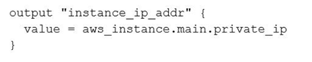
- 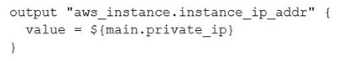
- 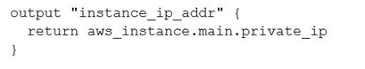
- 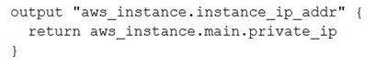

Answer 321
Correct Answer: A
B is incorrect because the name of the output can’t be the address of the resource

Question 322
When does Sentinel enforce policy logic during a Terraform Cloud run?
- Before the plan phase
- During the plan phase
- Before the apply phase
- After the apply phase

Answer 322
Correct Answer: C
Reference https://developer.hashicorp.com/sentinel/docs/terraform#:~:text=the%20sentinel%20integration%20with%20terraform%20runs%20within%20terraform%20enterprise%20after%20a%20terraform%20plan%20and%20before%20a%20terraform%20apply

Question 323
What is terraform refresh-only intended to detect?
- Empty state files
- Corrupt state files
- Terraform configuration code changes
- State file drift

Answer 323
Correct Answer: D
The terraform refresh-only command is intended to detect and reconcile any drift between the actual state of the infrastructure and the state described in the Terraform state file.

Question 324
You should run terraform fmt to rewrite all Terraform configurations within the current working directory to conform to Terraform-style conventions.
- True
- False

Answer 324
Correct Answer: A

Question 325
Why would you use the -replace flag for terraform apply?
- You want to force Terraform to destroy a resource on the next apply
- You want Terraform to ignore a resource on the next apply
- You want to force Terraform to destroy and recreate a resource on the next apply
- You want Terraform to destroy all the infrastructure in your workspace

Answer 325
Correct Answer: C

Question 326
You can configure Terraform to log to a file using the TF_LOG environment variable.
- True
- False

Answer 326
Correct Answer: B

Question 327
When does Terraform create the .terraform.lock.hcl file?
- After your first terraform plan
- After your first terraform apply
- After your first terraform init
- Whenever you enable state locking

Answer 327
Correct Answer: C
Terraform automatically creates or updates the dependency lock file each time you run the terraform init command.

Question 328
What is the best and easiest way for Terraform to read and write secrets form Hashicorp Vault?
- Api Access using the AppRole auth method
- Integration with a tool like Jenkins
- CLI access from the same machine running Terraform
- Vault provider

Answer 328
Correct Answer: D

Question 329
In Terraform Enterprise, a workspace can be mapped to how many VCS repos?
- 1
- 3
- 5
- 2

Answer 329
Correct Answer: A

Question 330
Hashicorp offers multiple versions of Terraform, including Terraform open-source, Terraform Cloud and Terraform Enterprise. Which of the following Terraform feature is only available in the Enterprise Edition? (select one).
- Audit Logs
- Private Network Connectivity
- Private Module Registry
- Locally managed installation
- SAML/SSO

Answer 330
Correct Answer: D

Question 331
Which Terraform command will force a resource to be destroyed and recreated even if there no configuration changes that would require it?
- terraform apply -replace=<address>
- terraform fmt
- terraform apply -refresh-only
- terraform destroy

Answer 331
Correct Answer: A

Question 332
What is the purpose of using the local-exec provisioner? (select two)
- executes a command on the resource to invoke an update to the Terraform state
- to invoke a local executable
- to execute one or more commands on the machine running Terraform
- ensures that the resource is only executed in the local infrastructure where Terraform is deployed

Answer 332
Correct Answer: BC

Question 333
Which of the following best describes a Terraform provider?
- serves as a parameter for a Terraform module that allows a module to be customized
- describes an infrastructure object, such a virtual network, compute instance, or other components
- a container for multiple resources that are used together
- a plugin that Terraform uses to translate the API interactions with the service or provider

Answer 333
Correct Answer: D

Question 334
Kristen is using modules to provision an Azure environment for a new application. She is using the following code and specifying a version of her virtual machine module to ensure she's calling the correct module.
Which of the following provides support for the versioning of a module? (select two)?
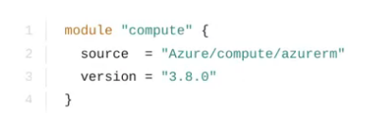
- public module registry
- local file paths
- modules stored in GitLab
- private module registry

Answer 334
Correct Answer: AD
Version constraints are supported only for modules installed from a module registry, such as the public Terraform Registry or Terraform Cloud's private module registry. Other module sources can provide their own versioning mechanisms within the source string itself or might not support versions at all. In particular, modules sourced from local file paths do not support version; since they're loaded from the same source repository, they always share the same version as their caller.
Reference: https://www.terraform.io/language/modules/syntax#version

Question 335
Select the answer below that completes the following statement:
Terraform Cloud can be managed from the CLI but requires ____________?

- a username and password
- authentication using MFA
- an API token
- a TOTPtoken

Answer 335
Correct Answer: C
Terraform Cloud requires it.

Question 336
What is the downside to using Terraform to interact with sensitive data, such as reading secrets from Vault?

- Terraform requires a unique auth method to work with Vault
- Terraform and Vault must be running on the same physical host
- Terraform and Vault must be running on the same version
- secrets are persisted to the state file.

Answer 336
Correct Answer: D

Question 337
Terry is using a module to deploy some EC2 instances on AWS for a new project. He is viewing the code that is calling the module for deployment, which is shown below. Where is the value of the security group originating?
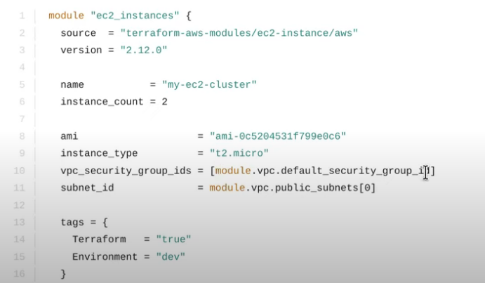

- from a variable likely declared in a .tfvars file being passed to another module
- the Terraform public module registry
- the output of another module
- an environment variable being using during a terraform apply.

Answer 337
Correct Answer: C

Question 338
In the example below, where is the value of the DNS record's IP address originating from?
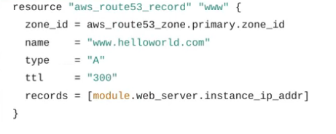
- the regular expression named module.web_server
- the output of a module named web_server
- value of the web_server parameter from the variables.tf file
- by querying the AWS EC2 API to retrieve the IP address

Answer 338
Correct Answer: B

Question 339
What does the command terraform fmt do?
- updates the font of the configuration file to the official font supported by HashiCorp
- formats the state file in order to ensure the latest state of resources can be obtained
- deletes the existing configuration file
- rewrite Terraform configuration files to a canonical format and style

Answer 339
Correct Answer: D

Question 340
Which of the following allows Terraform users to apply policy as code to enforce standardized configurations for resources being deployed via infrastructure as code?
- module registry
- workspaces
- sentinel
- functions

Answer 340
Correct Answer: C

Question 341
What Terraform feature is shown in the example below?
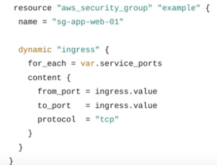
- Dynamic block
- Data source
- Conditional expression
- Local values

Answer 341
Correct Answer: A

Question 342
When configuring a remote backend in Terraform, it might be a good idea to purposely omit some of the required arguments to ensure secrets and other relevant data are not inadvertently shared with others.
What are the ways the remaining configuration can be added to Terraform so it can initialize and communicate with the backend? (select three)
- directly querying HashiCorp Vault for the secrets
- use the -backend-config=PATH to specify a separate config file
- interactively on the command line
- command-line key/value pairs

Answer 342
Correct Answer: BCD

Question 343
In order to make a Terraform configuration file dynamic and/or reusable, static values should be converted to use what?
- module
- regular expressions
- output value
- input variables

Answer 343
Correct Answer: D

Question 344
In regards to deploying resources in multi-cloud environments, what are some of the benefits of using Terraform rather than a provider's native tooling? (select three)
- Terraform is not cloud-agnostic and can be used to deploy resources across a single public cloud
- Terraform simplifies management and orchestration, helping operators build large-scale, multi-cloud infrastructure
- Terraform can manage cross-cloud dependencies
- Terraform can help businesses deploy applications on multiple clouds and on-premises infrastructure

Answer 344
Correct Answer: BCD

Question 345
After running into issues with Terraform, you need to enable verbose logging to assist with troubleshooting the error. Which of the following values provides the MOST verbose logging?
- ERROR
- DEBUG
- TRACE
- WARN
- INFO

Answer 345
Correct Answer: C

Question 346
By default, where does Terraform OSS/CLI store its state file?
- current working directory
- Amazon S3 bucket
- remotely using Terraform Cloud
- shared directory

Answer 346
Correct Answer: A

Question 347
You have been given requirements to create a security group for a new application. Since your organization standardizes on Terraform, you want to add this new security group with the fewest number of lines of code.
What feature could you use to iterate over a list of required tcp ports to add to the new security group?
- dynamic backend
- splat expression
- terraform import
- dynamic block

Answer 347
Correct Answer: D

Question 348
What happens when a terraform plan is executed?
- applies the changes required in the target infrastructure in order to reach the desired configuration
- the backend is initialized and the working directory is prepped
- reconciles the state Terraform knows about with the real-world infrastructure
- creates an execution plan and determines what changes are required to achieve the desired state in the configuration files

Answer 348
Correct Answer: D

Question 349
When using modules to deploy infrastructure, how would you export a value from one module to import into another module?
For example, a module dynamically deploys an application instance or virtual machine, and you need the IP address in another module to configure a related DNS record in order to reach the new/y deployed application.
- configure the pertinent provider's configuration with a list of possible IPaddresses to use
- preconfigure the IP address as a parameter in the DNS module
- configure an output value in the application module in order to use that value for the DNS module
- export the value using terraform export and input the value using terraform input

Answer 349
Correct Answer: C

Question 350
Given the Terraform configuration below, which order will the resources be created?
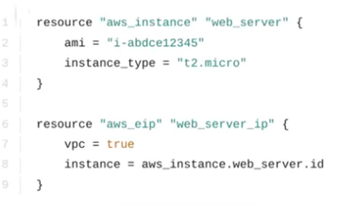
- resources will be created in parallel
- aws_eip will be created first & aws_instance will be created second
- no resources will be created
- aws_instance will be created first & aws_eip will be created second

Answer 350
Correct Answer: D

Question 351
Rick is writing a new Terraform configuration file and wishes to use modules in order to easily consume Terraform code that has already been written. Which of the modules shown below Will be created first?
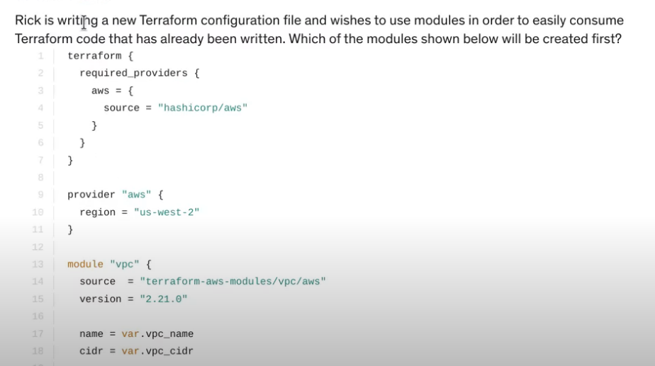
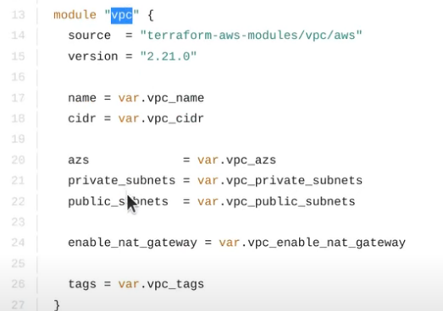
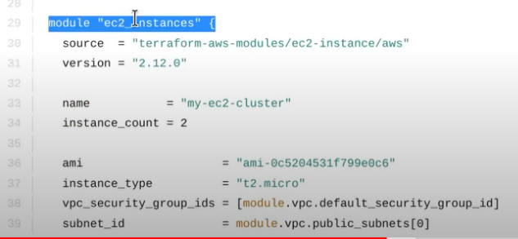
- module "ec2_instances"
- module "vpc"

Answer 351
Correct Answer: B

Question 352
What are some of the features of Terraform state? (select three)
- determining the correct order to destroy resources
- inspection of cloud resources
- increased performance
- mapping configuration to real-world resources

Answer 352
Correct Answer: ACD

Question 353
True or False? Starting in Terraform vO.12, the Terraform language now has built-in syntax for creating lists using the [ and ] delimiters, replacing and deprecating the list ( ) function.?
- True
- False

Answer 353
Correct Answer: A

Question 354
In the terraform block, which configuration would be used to identify the specific version of a provider required?
- required_versions
- required-provider
- required_providers
- required-version

Answer 354
Correct Answer: C

Question 355
In regards to Terraform state file, select all the statements below which are correct: (select four)
- storing state remotely can provide better security
- Terraform Cloud always encrypts state at rest
- the state file is always encrypted at rest
- the Terraform state can contain sensitive data, therefore the state file should be protected from unauthorized access
- when using local state, the state file is stored in plain-text
- using the mask feature, you can instruct Terraform to mask sensitive data in the state file

Answer 355
Correct Answer: ABDE

Question 356
From the answers below, select the advantages of using Infrastructure as Code. (select four)
- Easily change and update existing infrastructure
- Safely test modifications using a "dry run" before applying any actual changes
- Provide a codified workflow to develop customer-facing applications
- Provide reusable modules for easy sharing and collaboration
- Easily integrate with application workflows (GitLabActions, Azure DevOps, CI/CD tools)

Answer 356
Correct Answer: ABDE
Not C, we`re not deploying applications. Only infrastructure

Question 357
Which of the following best describes the default local backend?
- The local backend stores state on the local filesystem, locks the state using system APIS, and performs operations locally.
- The local backend is the directory where resources deployed by Terraform have direct access to in order to update their current state
- The local backend is how Terraform connects to public cloud services, such as AWS, Azure, or GCP.
- The local backend is where Terraform Enterprise stores logs to be processed by a log collector

Answer 357
Correct Answer: A

Question 358
True or False? Provisioners should only be used as a last resort.
- True
- False

Answer 358
Correct Answer: A

Question 359
What are the benefits of using Infrastructure as Code? (select five)
- Infrastructure as Code easily replaces development languages such as Go and .Net for application development
- Infrastructure as Code is relatively simple to learn and write, regardless of a user's prior experience with developing code
- Infrastructure as Code is easily repeatable, allowing the user to reuse code to deploy similar, yet different resources
- Infrastructure as Code allows a user to turn a manual task into a simple, automated deployment
- Infrastructure as Code gives the user the ability to recreate an application's infrastructure for disaster recovery scenarios
- Infrastructure as Code provides configuration consistency and standardization among deployments

Answer 359
Correct Answer: BCDEF
No A, we’re deploying infra, not applications

Question 360
Which of the following is considered a Terraform plugin?
- Terraform logic
- Terraform tooling
- Terraform language
- Terraform provider

Answer 360
Correct Answer: D

Question 361
What are the core Terraform workflow steps to use infrastructure as code?
- 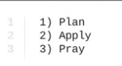
- 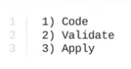
- 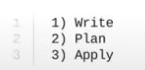
- 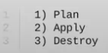

Answer 361
Correct Answer: C

Question 362
Which of the following represents a feature of Terraform Cloud that is NOT free to customers?
- workspace management
- team management and governance
- private module registry
- VCS integration

Answer 362
Correct Answer: B

Question 363
Terraform-specific settings and behaviors are declared in which configuration block type?
- data block
- terraform block
- provider block
- resource block

Answer 363
Correct Answer: B

Question 364
What are some of the problems of how infrastructure was traditionally managed before Infrastructure as Code? (select three)
- Traditional deployment methods are not able to meet the demands of the modem business where resources tend to live days to weeks, rather than months to years
- Traditionally managed infrastructure can’t keep up with cyclic or elastic applications
- Pointing and clicking in a management console is a scalable approach and reduces human error as businesses are moving to a multi-cloud deployment model
- Requests for infrastructure or hardware often required a ticket, increasing the time required to deploy applications

Answer 364
Correct Answer: ABD

Question 365
Why is it a good idea to declare the required version of a provider in a Terraform configuration file?
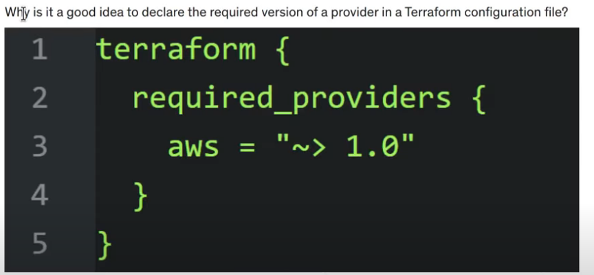
- to remove older versions of the provider
- providers are released on a separate schedule from Terraform itself; therefore, a newer version could introduce breaking changes
- to match the version number of your application being deployed via Terraform
- to ensure that the provider version matches the version of Terraform you are using

Answer 365
Correct Answer: B

Question 366
Stephen is writing brand new code and needs to ensure it is syntactically valid and internally consistent. Stephen doesn't want to wait for Terraform to access any remote services while making sure his code is valid. What command can he use to accomplish this?
- terraform validate
- terraform apply -refresh-only
- terraform fmt
- terraform show

Answer 366
Correct Answer: A

Question 367
Select two answers to complete the following sentence:
Before a new provider can be used, it must be ______ and ______. (select two)
- approved by HashiCorp
- initialized
- declared or used in a configuration file
- uploaded to source control

Answer 367
Correct Answer: BC

Question 368
After executing a terraform plan , you notice that a resource has a tilde (~) next to it. What does this mean?
- the resource will be destroyed and recreated
- the resource will be created
- the resource will be updated in place
- Terraform can't determine how to proceed due to a problem with the state file

Answer 368
Correct Answer: C

Question 369
Your organization has moved to AWS and has manually deployed infrastructure using the console. Recently, a decision has been made to standardize on Terraform for all deployments moving forward. What can you do to ensure that the existing resources are managed by Terraform moving forward without causing interruption to existing resources?
- delete the existing resources and recreate them using new a Terraform configuration so Terraform can manage them moving forward
- resources that are manually deployed in the AWS console cannot be imported by Terraform
- submit a ticket to AWS and ask them to export the state of all existing resources and use terraform import to import them into the state file
- using terraform import , import the existing infrastructure into your Terraform state

Answer 369
Correct Answer: D

Question 370
Which of the following Terraform files should be ignored by Git when committing code to a repo? (select two)
- terraform.tfvars
- output.tf
- terraform.tfstate
- variables.tf

Answer 370
Correct Answer: AC

Question 371
What Terraform command can be used to inspect the current state file?
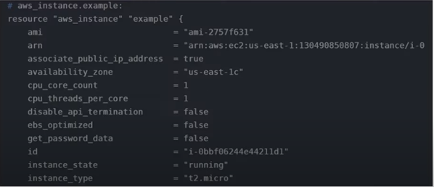
- terraform read
- terraform show
- terraform state
- terraform inspect

Answer 371
Correct Answer: B

Question 372
Select the feature below that best completes the sentence:
The following list represents the different types of _____ available in Terraform.
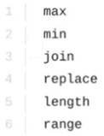
- data sources
- backends
- named values
- functions

Answer 372
Correct Answer: D

Question 373
Which of the following connection types are supported by the remote-exec provisioner? (select two)
- smb
- winrm
- ssh
- rdp

Answer 373
Correct Answer: BC

Question 374
True or False? State is a requirement for Terraform to function.
- False
- True

Answer 374
Correct Answer: B

Question 375
True or False? Workspaces provide similar functionality in the open-source, Terraform Cloud, and Enterprise versions of Terraform.
- False
- True

Answer 375
Correct Answer: B

Question 376
Published modules via the Terraform Registry provide which of the following benefits? (select four)
- support from any code repo
- show examples and READMEs
- allow browsing version histories
- support versioning
- automatically generated documentation

Answer 376
Correct Answer: BCDE

Question 377
What happens when a terraform apply command is executed?
- the backend is initialized and the working directory is prepped
- reconciles the state Terraform knows about with the real-world infrastructure
- creates the execution plan for the deployment of resources
- applies the changes required in the target infrastructure in order to reach the desired configuration

Answer 377
Correct Answer: D

Question 378
Frank has a file named main.tf which is shown below. Which of the following statements are true about this code? (select two)
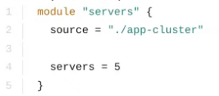
- app-cluster is the calling module
- main.tf is the calling module
- main.tf is the child module
- app-cluster is the child module

Answer 378
Correct Answer: BD

Question 379
Using multi-cloud and provider-agnostic tools provides which of the following benefits? (select two)
- slower provisioning speed allows the operations team to catch mistakes before they are applied
- operations teams only need to learn and manage a single tool to manage infrastructure, regardless of where the infrastructure is deployed
- increased risk due to all infrastructure relying on a single tool for management
- can be used across major cloud providers and VM hypervisors

Answer 379
Correct Answer: BD

Question 380
True or False? You can migrate the Terraform backend but only if there are no resources currently being managed.
- False
- True

Answer 380
Correct Answer: A

Question.
Body.

Answer
Correct Answer:
Explanation:
Discussion: https://hyperlink

